CHAPTER

## 11 ALCOHOLS, PHENOLS AND ETHERS

*Animation 11.1:* [*Hanau Alcohol Torch*](http://i.imgur.com/dX56Y.gif)

*Source and Credit :* [*reddit*](https://www.reddit.com/)

**IN THIS CHAPTER YOU WILL LEARN:**

1. How to name simple monohydric and polyhydric alcohols and their classification as primary, secondary and tertiary alcohols.
2. The important synthetic reactions leading to alcohols and industrial processes for the manufacture of methanol and ethanol.
3. The nature of OH group and its reactivity when O-H bond is broken and when C-O bond is broken.
4. To distinguish chemically between the primary, secondary and tertiary alcohols.
5. The methods of preparation of phenol and its acidic nature.
6. The importance of phenol as starting material for the preparation of five industrially important compounds.
7. How to name ethers and preparation of diethyl ether.
8. The physical . and chemical behaviour of diethyl ether and its inertness towards chemical reagents.

### 11.1 INTRODUCTION

Alcohols, phenols and ethers are classes of organic compounds which are much closer to water in structure and hence considered as derivatives

of water. *Animation 11.2:* [*Alcohol*](http://rationalwiki.org/w/images/b/ba/EtOHrotate.gif)

*Source and Credit :* [*rationalwiki*](http://rationalwiki.org/)

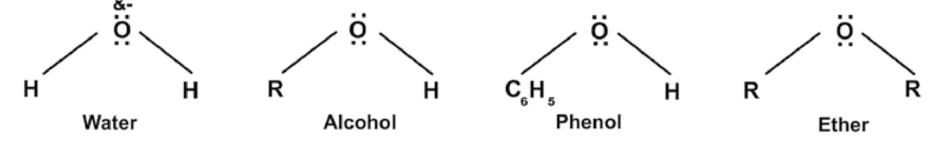

Alcohols and phenols are much more close to one another in structure and proper ties. Both contain hydroxyl (-OH) group so they may also be termed as hydroxy derivatives of alkanes and benzene respectively. In ether both hydrogens of water are replaced by alkyl or phenyl groups.

### 11.2 ALCOHOLS

They are represented by a general formula ROH where R is an alkyl group which maybe CH3— ,CH3CH2 — , (CH3)2C H — and C6H5 — CH2— ,etc. **Classification**

Alcohols are classified into monohydric and polyhydric alcohols. Monohydric alcohols contain one -OH group while polyhydric alcohols may contain two, three or more OH groups and named as dihydric or trihydric alcohols, etc.

Monohydric alcohols are further classified into primary, secondary and tertiary alcohols. In primary alcohols, -OH functional group is attached with primary carbon atom, in secondary alcohols with secondary carbon atom and in tertiary alcohols it is attached with a tertiary carbon atom.

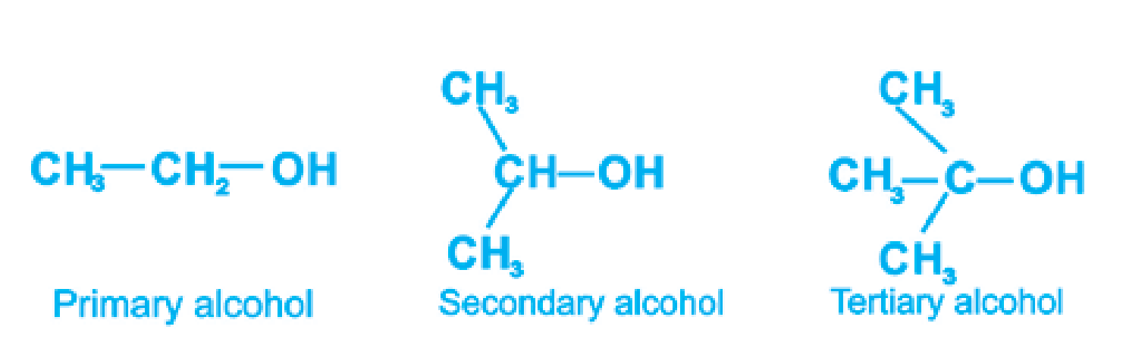

#### 11.2.1 NOMENCLATURE OF ALCOHOLS

There are two systems of naming alcohols

**Common or Trivial Names**

|  |
| --- |
| 2 3 |

1. Lower and simpler alcohols are usually known by their common or trivial names, obtained by adding the name of alcohol after the name of the alkyl group to which the OH group is attached, e.g., CH OH C H OH C H CH OH3 2 5 6 5 2 Methyl alcohol Ethyl alcohol Benzyl alcohol
2. **I.U.RA.C Names**

In this system the alcohols are named according to the following rules. (i) The longest chain of carbon atoms containing the hydroxyl group is taken as parent hydrocarbon. The ending ‘e’ of alkane is replaced by ol, e.g;

CH OH C H OH C H OH3 3 7 5 11

Methanol Propanel Pentanol

1. The position of OH group is indicated by a number placed before the name. The carbon chain is numbered, starting from the end where carbon atom attached with OH group gets the lowest possible number, e.g;

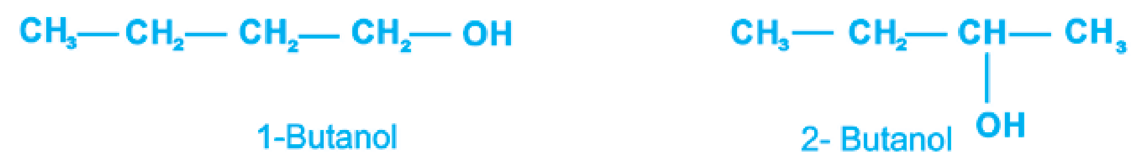

1. If more than one OH groups are attached, they are indicated by an appropriate suffix diol, triol, etc., e.g;

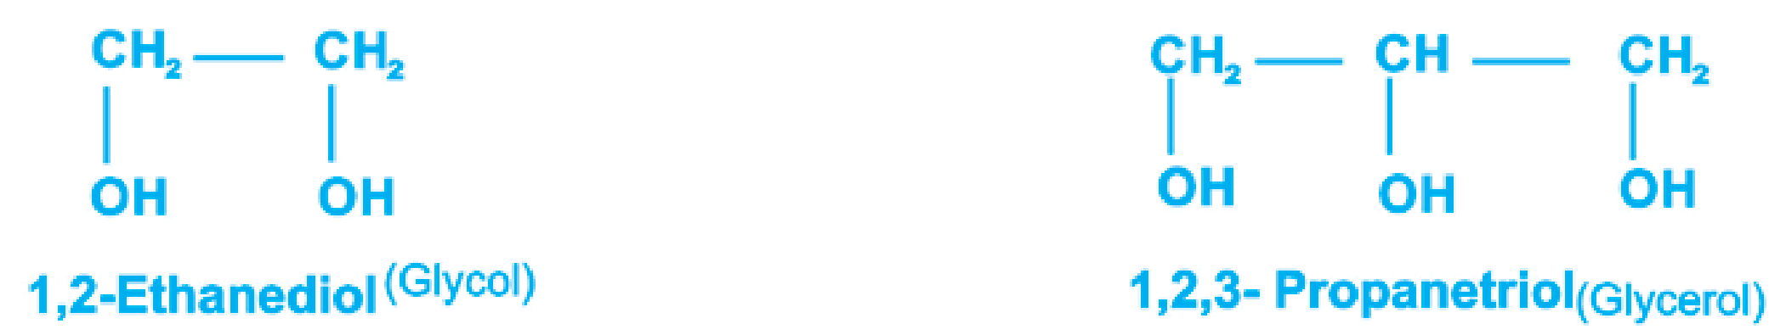

1. The unsaturated alcohols are numbered in such a way that hydroxyl group rather than the point ot unsaturation gets the lower number, e.g.

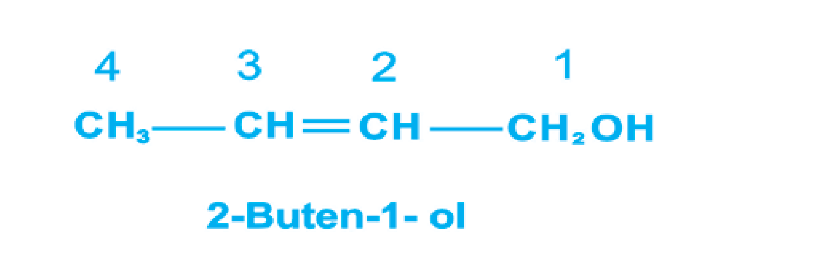

1. When hydroxyl group is not a preferred functional group as in hydroxy acids, aldehydes and ketones, the substituent name hydroxy is used as a prefix to indicate the position of OH group, e.g.;

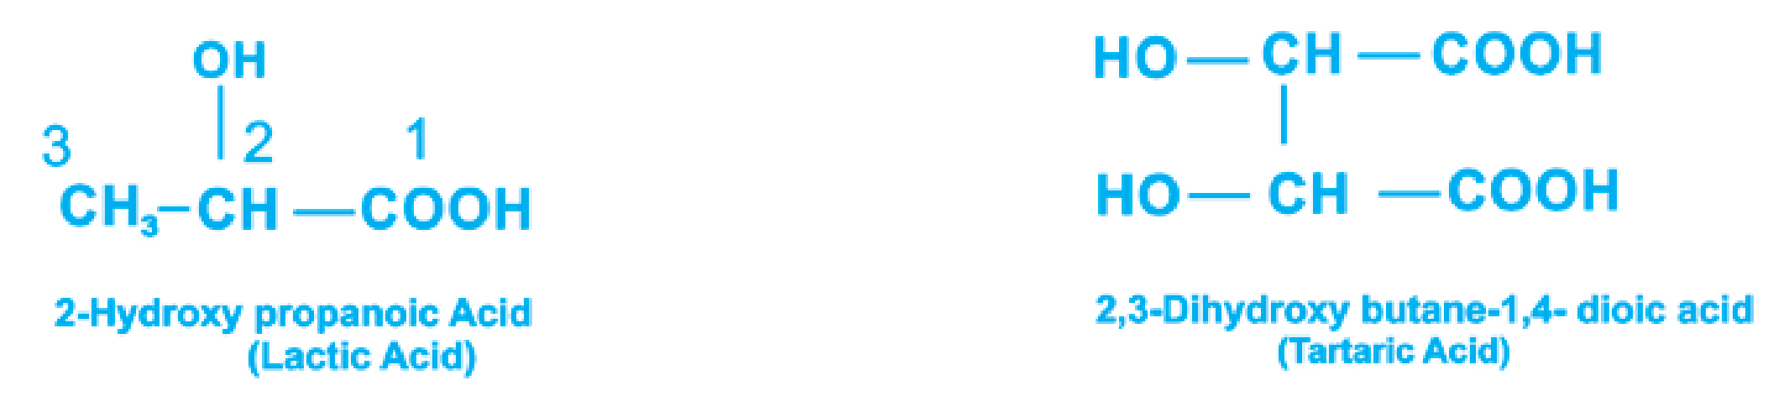

The names of some alcohols in the two systems are given below

**Formula Common Name IUPAC Name** CH3OH Methyl alcohol methanol CH3 CH2OH Ethyl alcohol Ethanol

CH3CH2CH2OH Propyl alcohol 1-Propanol

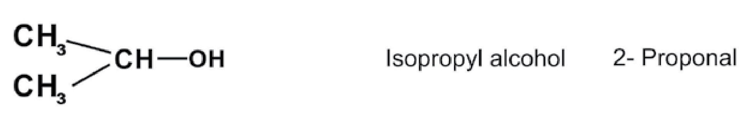

|  |
| --- |
| 5 |

#### CH3 CH2 CH2 CH2 OH n-Butyl alcohol 1-Butanol

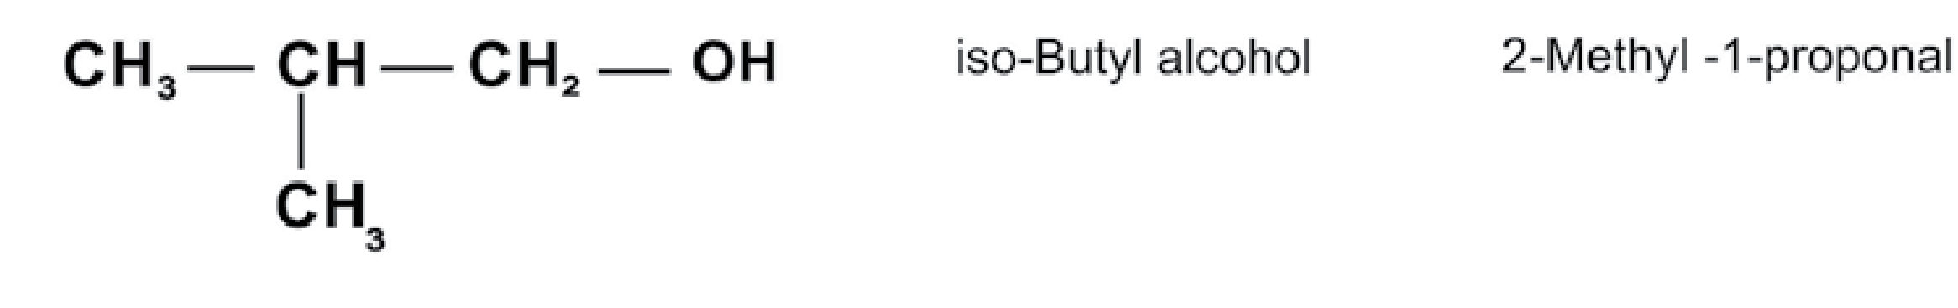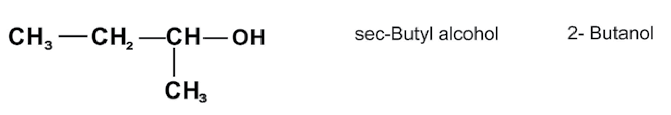

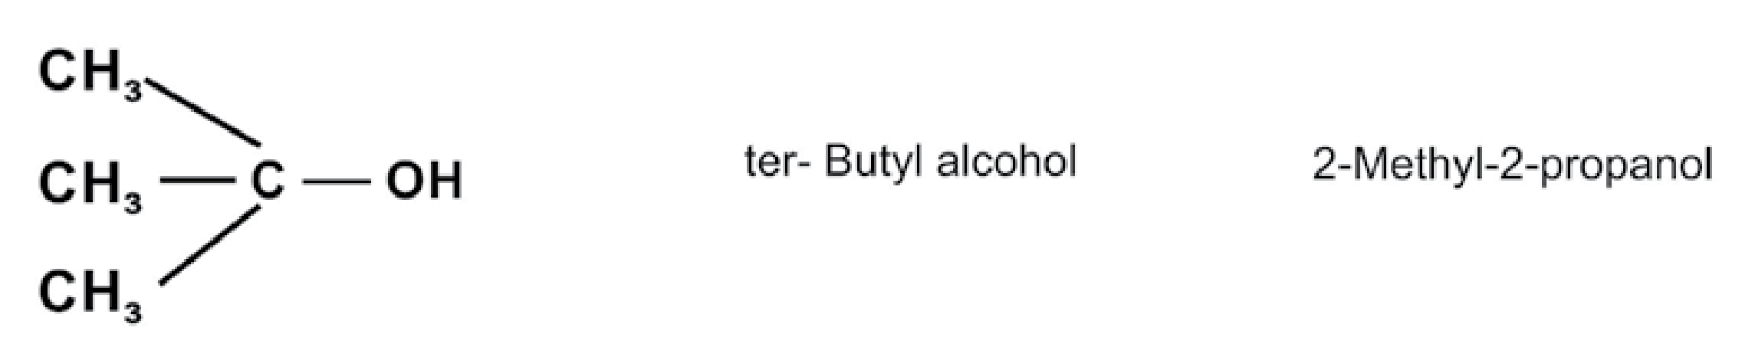

##### 11.2.2 Industrial Preparation of Alcohols Methanol

Formerly methanol was prepared by distillation of wood. That is why it is also called as wood spirit. Now-a-days methanol is prepared from carbon monoxide and hydrogen or water gas as follows: CO+2H2 →450(ZnO+Cr O°C:200atm2 3) CHOH3

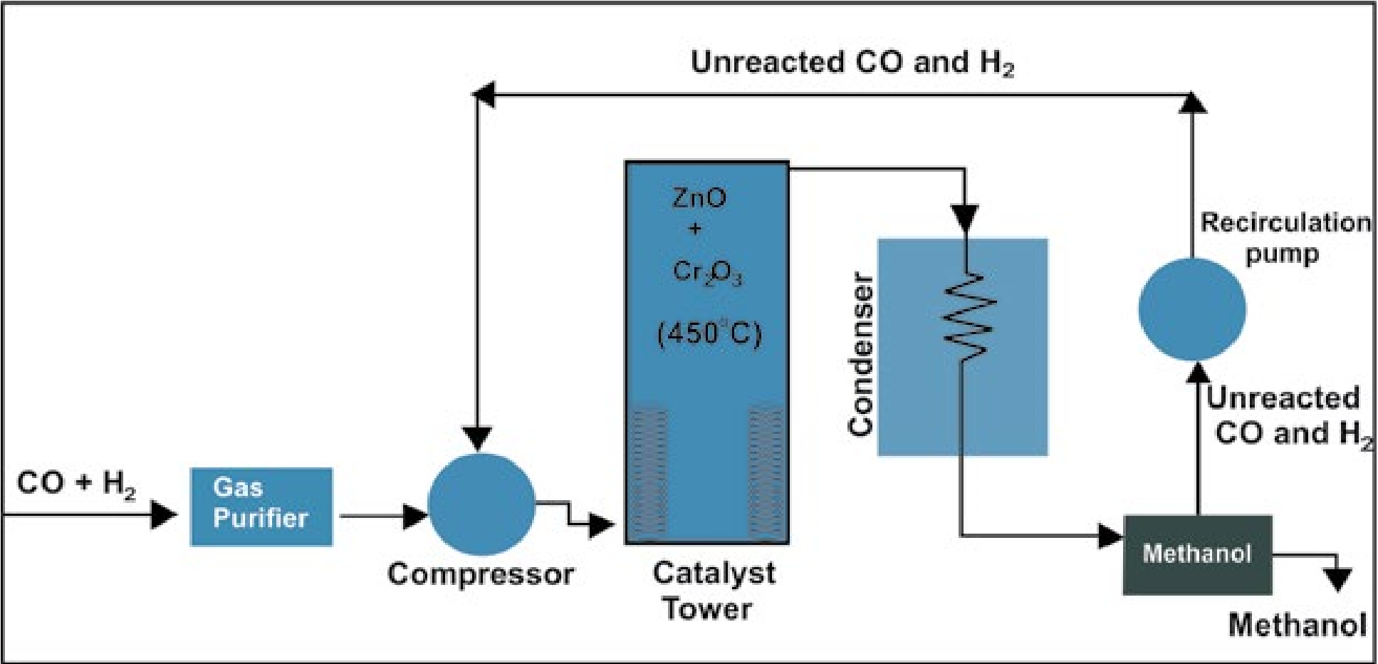

Fig. 11.1 Flow sheet diagram for the manufacturing of methanol

First of all a mixture of carbon monoxide and hydrogen is purified. It is compressed under a pressure of 200 atmospheres and taken into a reaction chamber by means of coiled pipes Here the catalyst is heated upto 450500 OC. Gases react to form methanol vapours. These vapours are passed through a condenser to get methanol. Unreacted gases are recycled through compressor to reaction chamber.

*Animation 11.3:* [*ethyl methanoate*](http://www.dynamicscience.com.au/tester/solutions1/chemistry/organic/animatedester.gif)

*Source and Credit :* [*dynamicscience*](http://www.dynamicscience.com.au/)

##### Ethanol

Ethanol is prepared on industrial scale world over, by the process of fermentation. Fermentation is a biochemical process which occurs in the presence of certain enzymes secreted by microorganisms such as yeast. Optimum temperature for this process of fermentation is 25-35°C. Moreover, proper aeration, dilution of solution and the absence of any preservative are essential conditions for fermentation. In Pakistan ethanol is prepared by the fermentation of molasses starch grains or fruit juices.

**From Molasses**

The residue obtained after the crystallization of sugar from concentrated sugar cane juice is called molasses. It undergoes fermentation in the presence of enzymes present in yeast to give ethanol.

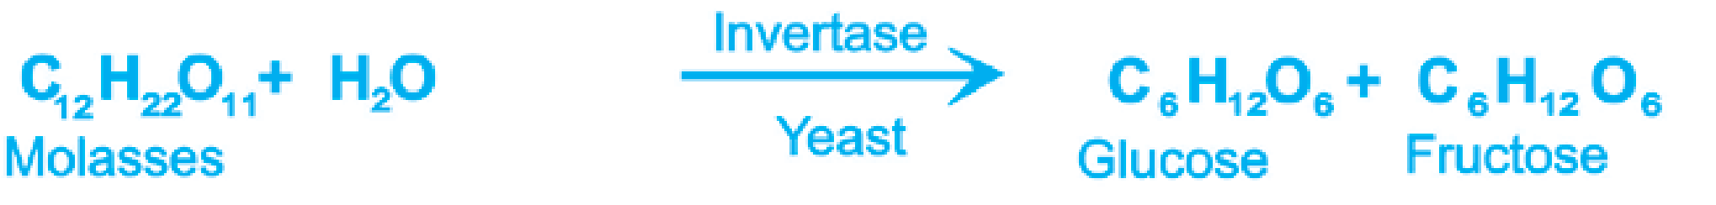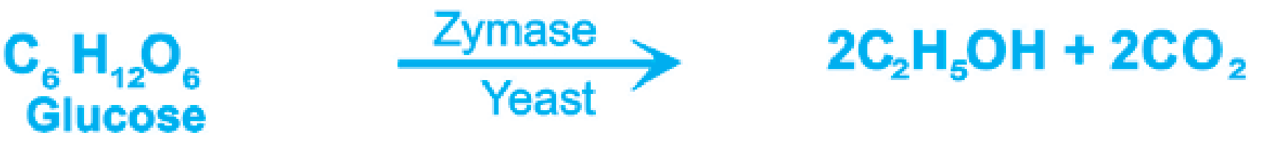

##### From Starch

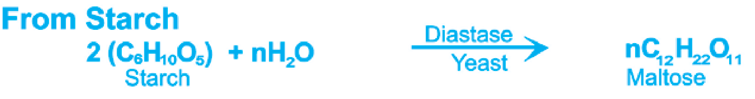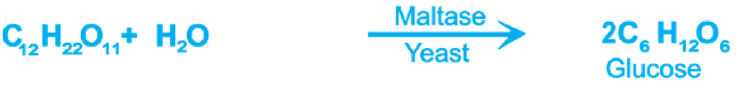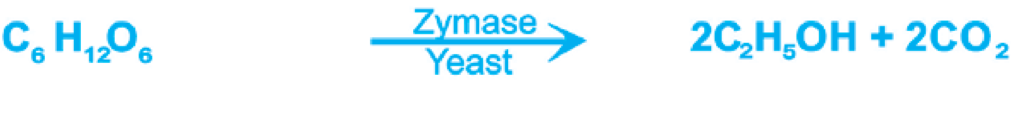

|  |
| --- |
| 6 7 |

Alcohol obtained by fermentation is only upto 12% and never exceeds 14% because beyond this limit enzymes become inactive. This alcohol is distilled again and again to obtain 95% alcohol which is called rectified spirit. Absolute alcohol can aioo be obtained by redistillation of rectified spirit in the presence of CaO which absorbs its moisture.

##### Denaturing of Alcohol

Sometimes ethanol is denatured by addition of 10% methanol to avoid its use for drinking purposes. Such alcohol is called methylated spirit. A small quantity of pyridine or acetone may also be added for this purpose.

##### Other Methods of Preparation of Alcohols

Alcohols can be obtained by the hydration of aikenes and by the reaction of Grignard reagents with aldehydes or ketones. Both these methods have already been discussed in the previous chapter.

###### 11.2.3 Physical Properties

Lower alcohols are generally colourless toxic liquids with characteristic sweet smell and burning taste They are readily soluble in water but solubility decreases in higher alcohols. The solubility of alcohols is due to hydrogen bonding which is prominent in lower alcohols but diminishes in higher alcohols.

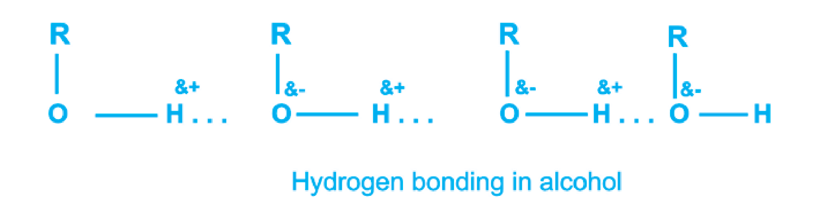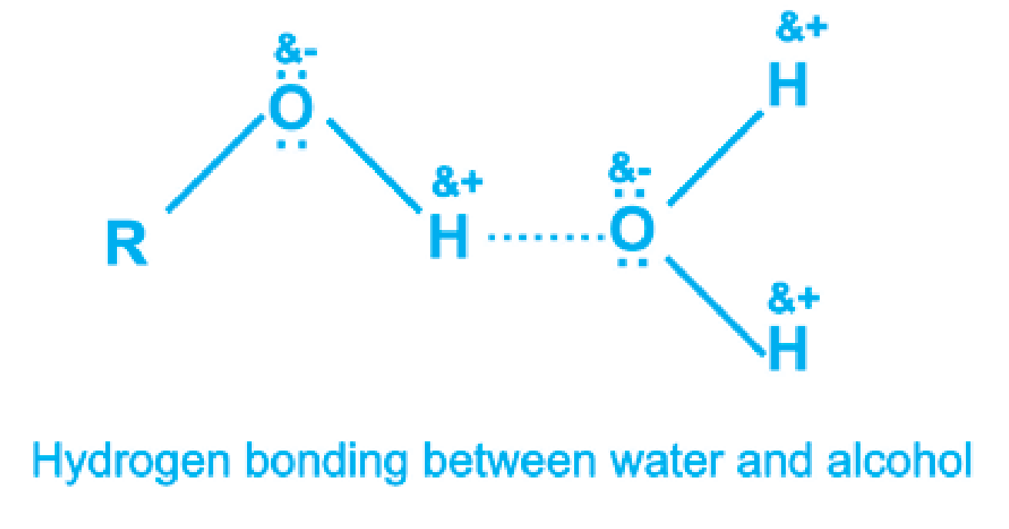

Melting and boiling points of alcohols are higher than corresponding alkanes. Methyl alcohol and ethyl alcohol are liquids while methane and ethane are gases. This is also due to hydrogen bonding which is present in alcohols but absent in alkanes.

###### 11.2.4 Reactions of Alcohols

Alcohols react with other reagents in two ways

1. Reactions in which C — O bond breaks
2. Reactions in which O — H bond breaks

Which bond will break depends upon the nature of the attacking reagent.

If a nucleophile attacks, it is the C — O bond which breaks. On the other hand, if an electrophile attacks on alcohol, it is the O — H bond which breaks.

CH3 CH2δ+OHδ− →Nucleophile CH3 CH2+ +OH-

CH3 CH2 Oδ− Hδ+ →Electrophile CH3 CH2 O +H− +

The order of reactivity of alcohols when C — O bond breaks:

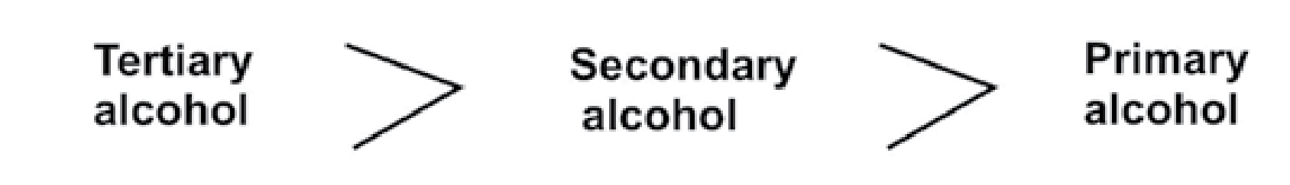

The order of reactivity of alcohols when O — H bond breaks:

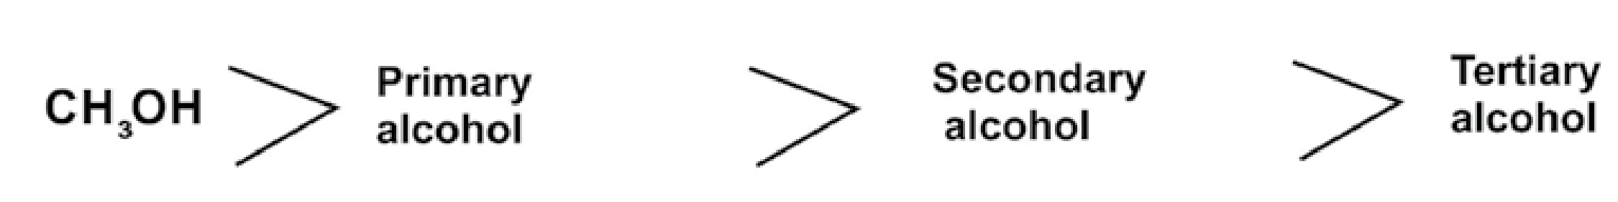

**11.2.5 Reactions in w hich C — O Bond is Broken.**

### 1 C H OH + SOCl2 5 2 →pyridine C H Cl + SO + HCl2 5 2

Ethanol Thionyl Ethyl chloride

chloride

8 9

2 C H OH + HCl2 5 →ZnCl2 C H Cl + H O2 5 2

### 3 C H OH + HNH2 5 2 →ThO2 C H NH + H O2 5 2 2

Ethyl amine

**11.2.6 R eactions Involving the Cleavage of O — H bond.**

#### 1 2C H OH + 2Na2 5 → 2C H O N a +H2 5 − + 2

Sodium cthoxide

2 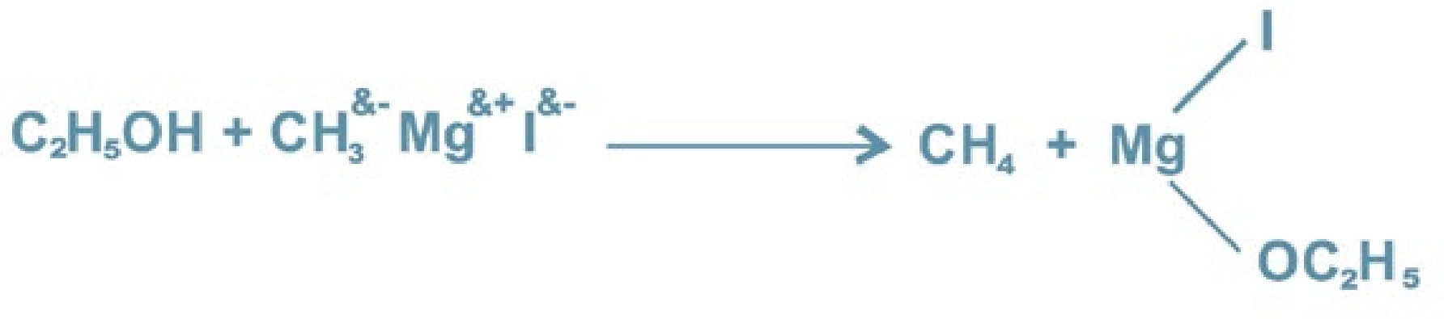

### 3 C H OH + CH COOH2 5 3  H SO2 4 CH COOC H + H O3 2 5 2

Ethyl acetate

#### 11.2.7 Some Other Reactions of Alcohols

**(i) Oxidation**

Oxidation of alcohols convert them into aldehydes and ketones. The best reagent for this purpose is acid dichromate.

#### CH -CH OH + [O]3 2 →K Cr OH SO2 2 72 4 CH -CHO + H O3 2

E thanal (acetaldehyde)

10

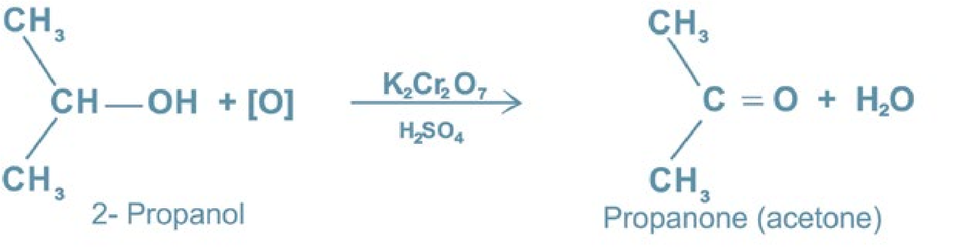

Tertiary alcohols are resistant to oxidation. In the presence of acid dichromate they undergo elimination reactions to give alkenes.

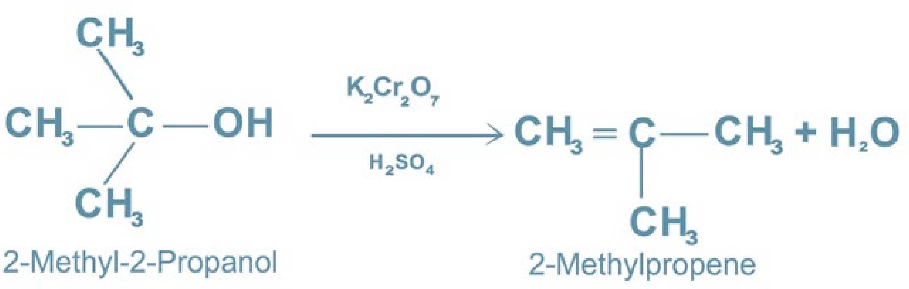

1. **Dehydration**

Alcohols react with con. H2SO4 and give different products at different temperatures.

C H OH2 5 →conc.H SO180°2c 4 CH = CH + H O2 2 2

Ethanol

2C H OH2 5 →conc.H SO140°2C 4 C H OC H + H O2 5 2 5 2

DiethyI ether

1. **Reactions with Phosphorus Halides PCI3, PCI5**

3C H OH + PCl2 5 3 →3C H Cl + H PO2 5 3 3

### C H OH + PCl2 5 5 → C H Cl + POCl + HCl2 5 3

11

#### 11.3 DISTINCTION BETWEEN PRIMARY, SECONDARY AND TERTIARY ALCOHOLS

**Lucas Test**

Primary, secondary and tertiary alcohols are identified and distinguished by reacting them with con. HCI in anhydrous ZnCI2. An oily layer of alkyl halides separates out in these reactions.

1. Tertiary alcohols form an oily layer immediately
2. Secondary alcohols form an oily layer in five tc ten minutes.
3. Primary alcohols form an oily layer only on heating.

R CH2 OH + HCl→ZnClHeat2 R CH2 Cl + H O2

Primary alcohol Primary alkyl chloride

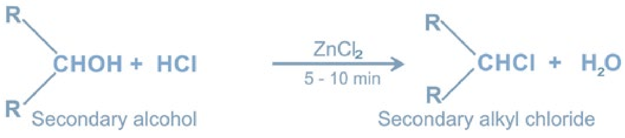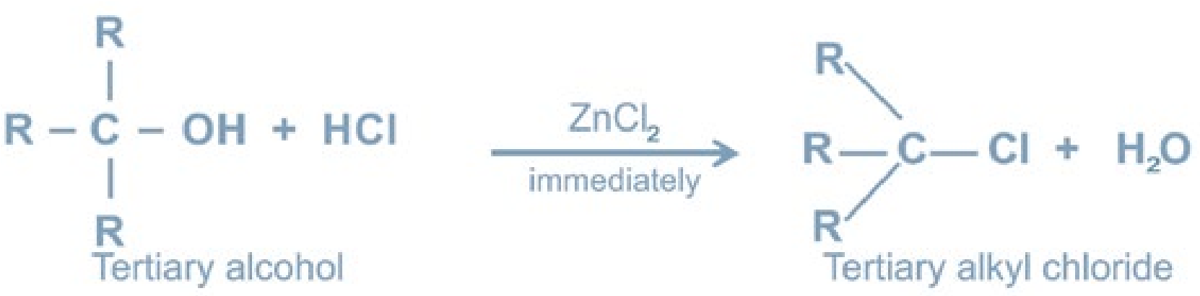

**Distinction between Methanol and Ethanol**

Ethanol gives iodoform with iodine in the presence of NaOH. Formation of yellow crystals indicate that the alcohol is ethanol. Methanol does not give iodoform test.

12

C H OH + 4I + 6NaOH2 5 2 → CHI + HCOONa + 5NaI + 5H O3 2

Iodoform

CH OH + I + NaOH3 2 → No yellow ppt

#### 11.4 USES OF ALCOHOLS

Methanol is used as a solvent for fats oils, paints, varnishes. It is also used as antifreeze in the radiators of automobiles and for denaturing of alcohol.

Ethanol is used as a solvent, as a drink and as a fuel in some countries. Moreover it. is used in pharmaceutical preparations and as a preservative for biological specimen.

#### 11.5 PHENOL

Aromatic compounds which contain one or more OH groups directly attached with carbon of benzene ring are called Phenols. The simplest example is phenol which is also known as Carbolic acid i.e. C6H5OH. It was first obtained from coaltar by Runge in 1834.

##### 11.5.1 Preparation of Phenol

1. **From Chlorobenzene (Dow's**

**Method)**

In this method chlorobenzene is treated with 10% NaOH at 360°C and 1I50 atmospheres pressure. Sodium phenoxide is produced which on treating with HCI gives phenol. *Animation 11.4:* [*Phenol*](http://chem.utah.edu/_images/faculty/anderson/phenolcat7.gif)

*Source and Credit :* [*chem*](http://chem.utah.edu/)

13

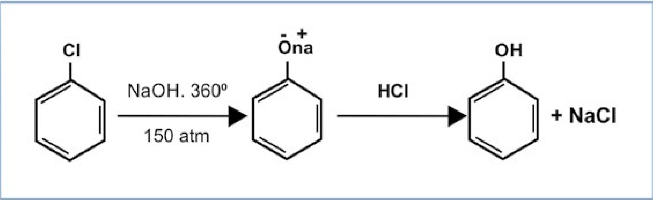

1. **From Sodium Salt of Benzen e Sulphonic Acid**

Sodium salt of benzene sulphonic acid reacts with NaOH aT 320°C tc give sodium phenoxide which cn treatment with HC1 gives phenol.

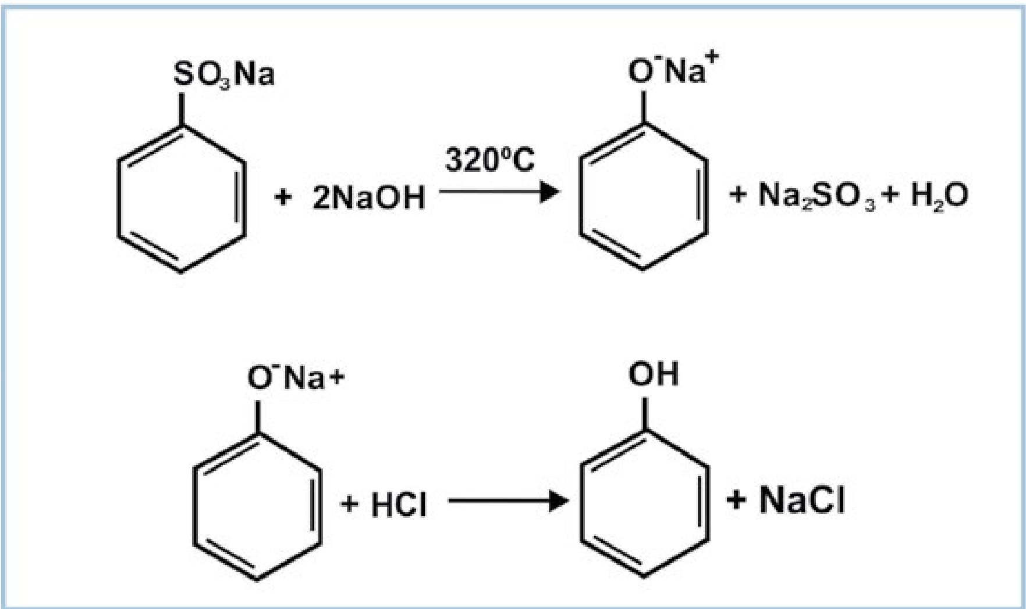

The phenol is recovered by steam distillation.

##### 11.5.2 Physical Properties

Phenol is a colourless, crystalline, deliquescent solid with characteristic phenolic odour having melting point 41°C and boiling point 182°C. It is sparingly soluble in water forming pink solution at room temperature but completely soluble above 68.5°C. It is poisonous and used as a disinfectant in hospitals and washrooms.

14

*Animation 11.5:* [*Physical Properties of phenol*](http://chemwiki.ucdavis.edu/Core/Analytical_Chemistry/Chemical_Reactions/Properties_of_Matter)

*Source and Credit :* [*chemwiki*](http://chemwiki.ucdavis.edu/)

##### 11.5.3 Reactions of Phenol

Phenol shows two type of reactions.

1. Reactions due to — OH group
2. Reactions due to benzene ring

Phenols are less reactive to nucleophiles so nucleophilic attack is less favoured, i.e - OH is not easy to replace while electrophilic attack on the ring is easy. **11.5.4 Acidic Behaviour of Phenol**

Phenol is much more acidic than alcohols but less acidic than carboxylic acids. It dissolves readily in alkalies but it is too weak to affect the litmus paper or to evolve CO2 from carbonates. Its dissociation constant

(Ka) is 1.3xl0-10.

Phenol is partially soluble in water and its solution has a pH of around 5 or 6. This makes phenol different from aliphatic alcohols.

15

The reason why phenol is acidic lies in the nature of the phenoxide ion. The negative charge on oxygen atom can become involved with the p-electron cloud on the benzene ring. The negative charge is thus delocalized in the ring and the phenoxide ion becomes relatively stable. This type of delocalization is not possible with alcohols.

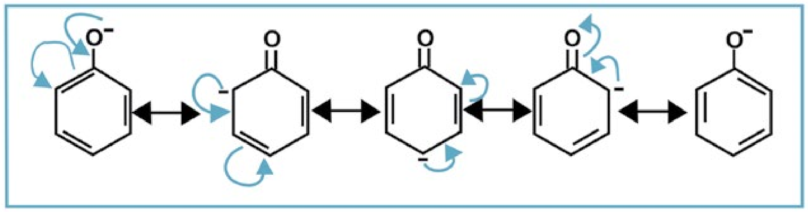

Relative acidic strength of alcohol, phenol, water and carboxylic acid is as follows,

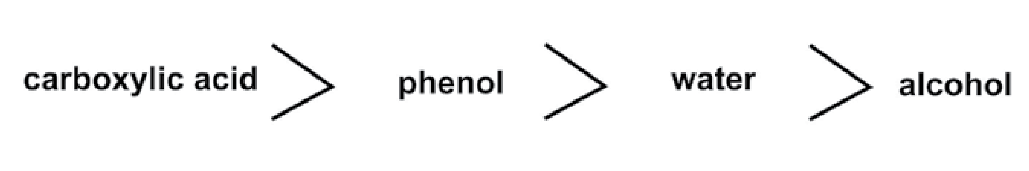

**11.5.5 Reactions of Phenol Due to - OH Group.**

**Salt Formation**

Phenol reacts with alkalies to form salts, e.g;

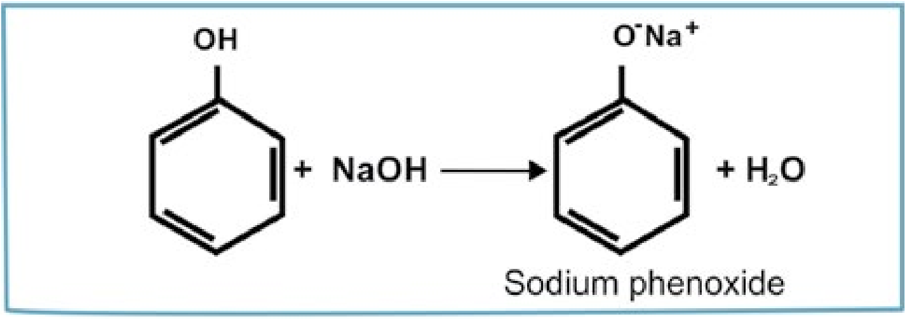

**Ester Formation**

Phenol reacts with acetyl chloride in the presence of a base to form ester.

16

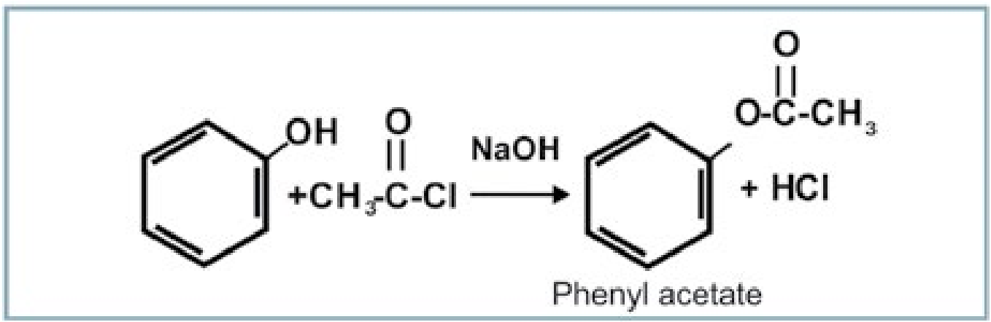

**Reduction with Zn**

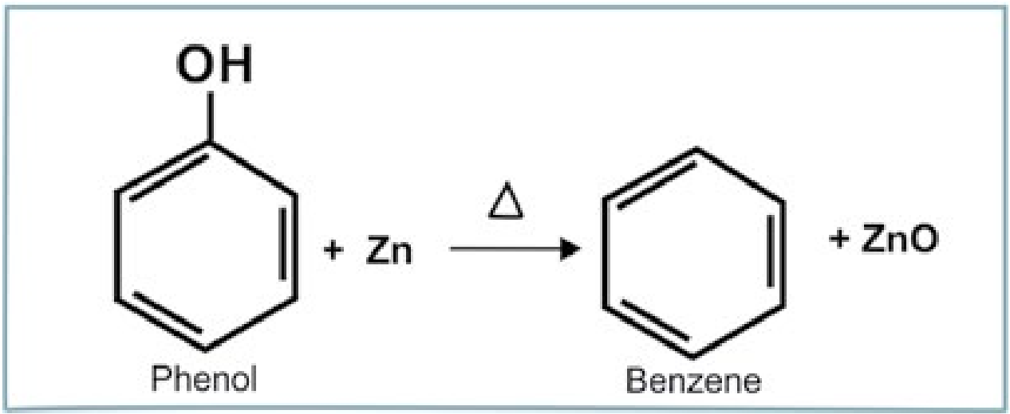

##### 11.5.6 Reactions of Phenol Due to Benzene Ring

**Nitration**

Phenol reacts with dil. and conc. HNO3 at different temperatures as follows.

17

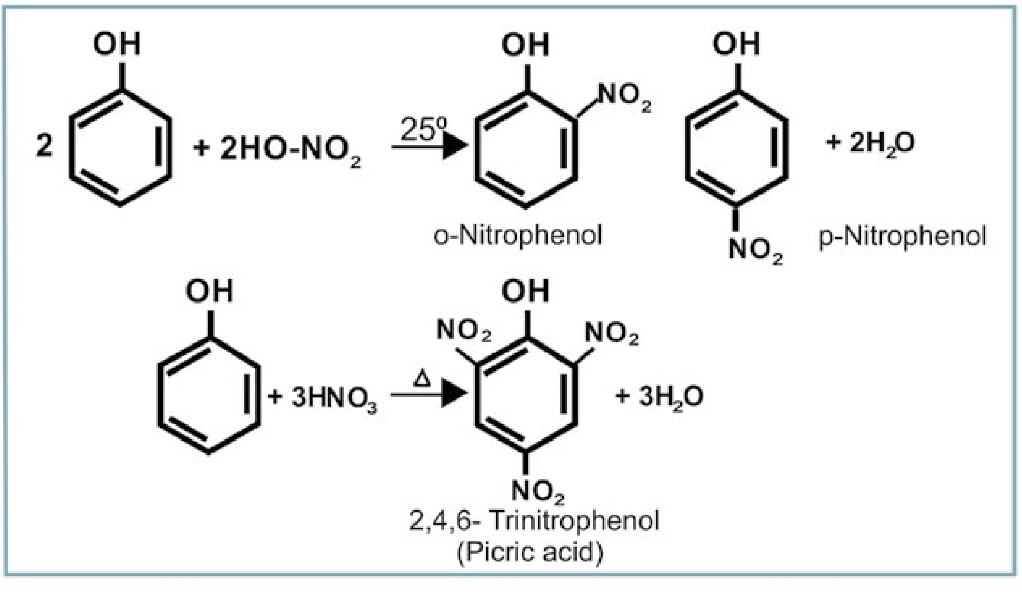

**Sulphonation**

Phenol reacts with conc. H2SO4 at room temperature giving ortho and para hydroxy benzene sulphonic acids.

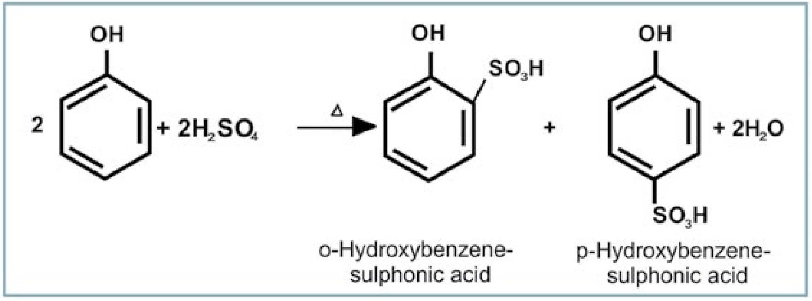

**Halogenation**

An aqueous solution of phenol reacts with bromine water to give white ppt. of 2,4,6- tribromophenol.

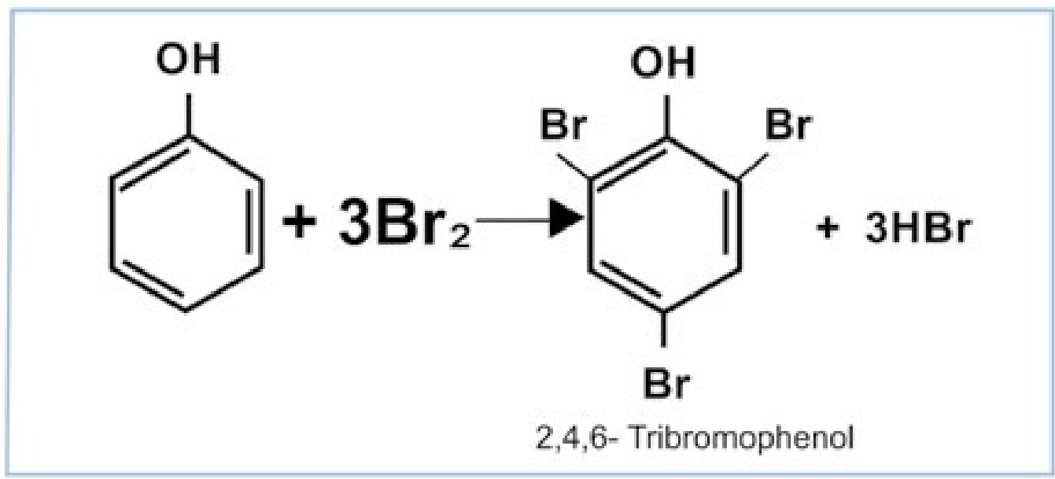

**Hydrogenation**

When hydrogen is passed through phenol at 150°C in the presence of Ni catalyst it gives cyclohexanol.

18

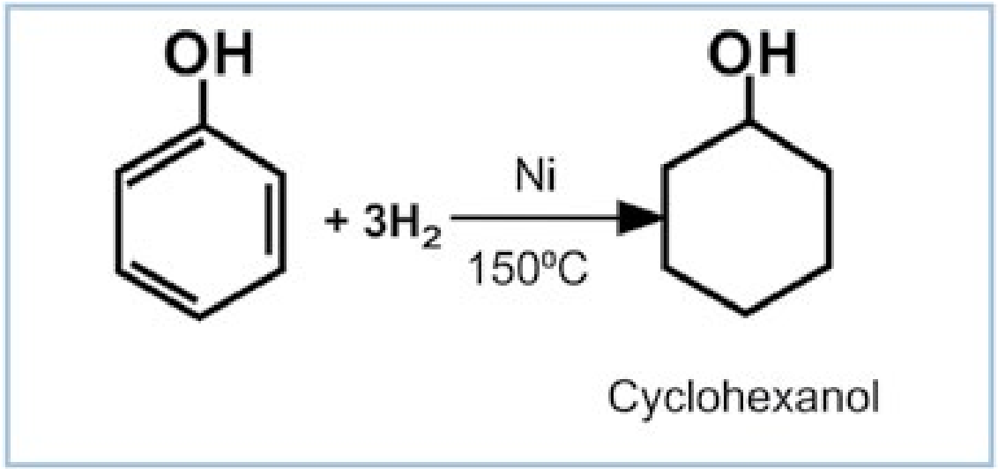

**Reaction with formaldehyde**

Phenol reacts with formaldehyde (methanal) in the presence of acid or alkali to give hydroxy benzyl alcohol which on further reaction with other phenol molecules yield a polymer called bakelite.

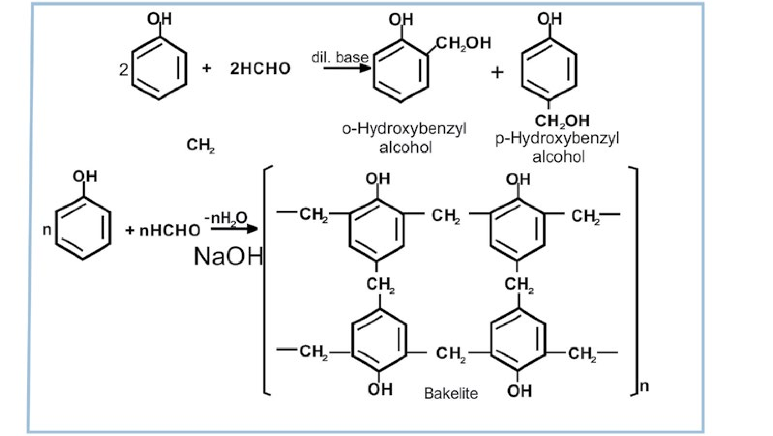

#### 11.6 ETHERS

Ethers are classified into two categories

1. Simple or symmetrical ethers, which contain two same alkyl groups e.g. dimethyl ether CH3OCH3 and diethyl ether CH3— CH2— O — CH2 — CH3.
2. Mixed or unsymmetrical ethers, which contain different alkyl or phenyl groups, e.g., ethyl methyl ether CH3— O — CH2 — CH3.

19

##### 11.6.1 Nomenclature

Ethers are named either by I.U.P.A.C. system or by common names. In I.U.P.A.C. system the large alkyl (R ) group is taken as parent molecule and given the last name (suffix) while the smaller alkyl group along with oxygen is used as prefix and given the name alkoxy (e.g.methoxy, ethoxy, propoxy, etc).

I. U.P. A. C. names are not common as they are difficult. Usually ethers are known by their common names, as given below;

|  |  |  |
| --- | --- | --- |
| **Formula** | **Common Names** | **I.U.P.A.C** |
| CH3OCH3 | Dimethyl ether | Methoxy methane |
| CH3OC2H5 | Methyl ethylether | Methoxy ethane |
| C2H5OC2H5 | Diethyl ether | Ethoxy ethane |
| C2H5O CH2 — CH2 — CH3 | Ethyl n-propylether | Ethoxy propane |
| CH OC H | Methyl phenyl ether | Methoxy benzene |

3 6 5

##### 11.6.2 Preparation of Ethers

Ethers are prepared from alcohols either directly or indirectly. Usually they are obtained by the following methods.

1. **By Williamsons synthesis**

Alcohols are reacted with metallic sodium to form alkoxides. This alkoxide ion is a strong nucleophile and readily reacts with alkyl halide to produce an ether.

2C H OH + 2Na2 5 → 2C H O Na + H2 5 − + 2

C H O Na + C H Br− + C H OC H + NaBr

2 5 2 5 → 2 5 2 5

20

1. **Alkyl halides are heated with dry silver oxide to form ethers**

2C H Br + Ag O2 5 2 → C H OC H + 2AgBr2 5 2 5

##### 11.6.3 Physical Properties

Usually ethers are volatile liquids, highly inflammable with low boiling points. They are slightly soluble in water but freely soluble in organic solvents. Ether molecules do not show hydrogen bonding with one another but they show weak hydrogen bonding with water molecules due to which they are slightly soluble in water.

##### 11.6.4 Chemical Reactivity

Ethers are comparatively inert substances. The reagents like ammonia, alkalies, dilute acids and metallic sodium, have no action on ethers in cold state. Moreover, they are not oxidized or reduced easily. However ethers show some reactions, e.g.

1. With hydrogen iodide ethers give alcohols which can react further to give alkyl iodides.

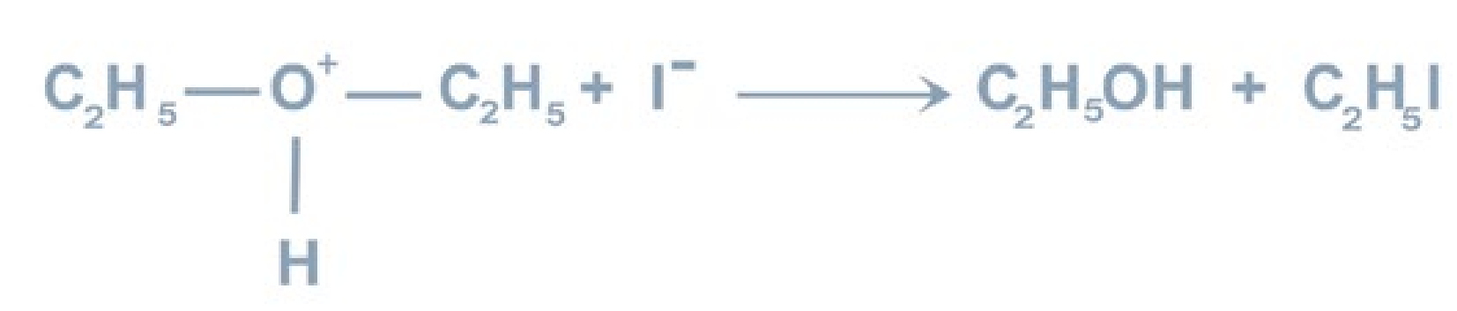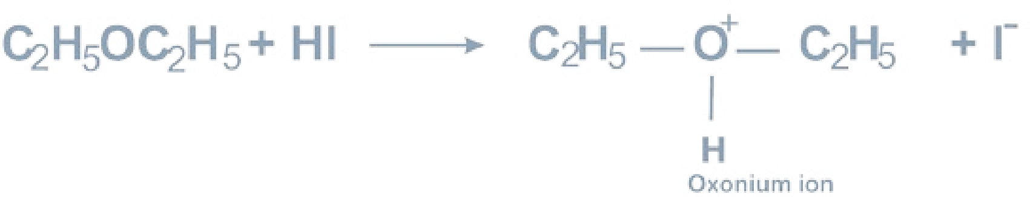

1. Ethers also react with hot phosphorus pentachloride to give alkyl chloride.

##### C H OH + 4I + 6NaOH2 5 2 → CHI + HCOONa + 5NaI + 5H O3 2

21

#### KEY POINTS

1. Alcohols and Phenols are hydroxy derivatives of aliphatic and aromatic hydrocarbons.
2. General formula for alcohol is ROH, for Phenol is Ph OH, and for ether it is ROR.
3. Alcohols are usually named by replacing ‘e’ for the alkane with ‘ol’.
4. In Pakistan ethanol is prepared commercially from molasses.
5. Fermentation is a biochemical phenomenon which may occur naturally or artificially.
6. Ethyl alcohol obtained by fermentation is less than 12% concentrated.
7. Ethyl alcohol gives different products when reacts with H2SO4 of different concentrations.
8. Ethyl alcohol is used as a solvent, as a beverage and as a fuel.
9. Primary, secondary and tertiary alcohols can be distinguished by Lucas test.
10. Picric acid is a phenol which behaves like an acid.

#### EXERCISE

1. Primary, secondary and tertiary alcohols can be identified by_______ test.
2. Oxidation of__________ alcohols give ketones.
3. Alcohols on heating with_________ give alkenes at high temperature.
4. Alcohols have________ boiling points than ethers due to stronger hydrogen bonding.
5. Williamsons synthesis is used to prepare________ .
6. ________is also called wood spirit.
7. Carbolic acid is the other name of________ .
8. Primary, secondary and tertiary alcohols can be prepared by reacting Grignard reagent with________ , ________ and ________.
9. Alcohols and________react to produce esters.
10. ________ is used as anti-freezing agent in automobile radiator.
11. The process of conversion of starch into alcohol with the help of microorganisms is called________ .
12. Ketones on reduction give________ alcohols.

22

**Q.2. Indicate True or False**

1. Methylated spirit contains 95% methyl alcohol and 5% ethyl alcohol.
2. Ethyl alcohol is a very good anti-freezing agent.
3. Methanol is also called wood spirit.
4. Only 14% ethyl alcohol can be prepared by fermentation.
5. Ethers do not show hydrogen bonding.
6. Alcohols are more acidic than phenols.
7. Phenol is more soluble in water than lower alcohols.
8. Alcohols are more basic than ethers.
9. Ethers have higher boiling points than alcohols and phenols.
10. Methanol and ethanol can be distinguished by iodoform test. **Q.3. Multiple Choice Questions. Encircle the correct answer.**

i) Which compound shows hydrogen bonding

a) C2H6 b) C2H5CI c) CH3-O-CH3 d) C2H5OH

ii) Which compound shows maximum hydrogen bonding with water?

a) CH3OH b) C2H5OH c)CH3-O-CH3 d) C6H5OH

iii) Which compound is more soluble in water

a) C2H5OH b) C6H5OH c) CH3COCH3 d) n-Hexanol

iv) Which compound will have the maximum repulsion with H2O?

a) C6H6 b) C2H5OH c) CH3CH2CH2OH d) CH3— O — CH3

v) Ethanol can be converted into ethanoic acid by

a) Hydrogenation b) Hydration c) Oxidation d) Fermentation

vi) Which enzyme is not involved in fermentation of starch?

a) Diastase b) Zymase c) Urease d)Invertase

vii) Which compound is called a universal solvent?

a) H2O b) CH3OH c) C2H5OH d) CH3— O — CH3

23

viii) Methyl alcohol is not used

a) as a solvent b) as an anti-freezing agent

c) as a substitute for petrol d) for denaturing of ethyl alcohol

ix) Rectified spirit contains alcohol methyl about

a) 80% b) 85% c) 90% d) 95%

x) According to Lewis concept ethers behave as

a) Acid b) Base

c) Acid as well as a base d) None of them

**Q.4.** What are alcohols. How are they classified? How will you distinguish between primary, secondary and tertiary alcohols?

**Q.5.** How is methyl alcohol obtained on large scale? How it may be distinguished from ethyl alcohol?

**Q.6.** What is fermentation? Which compound may be obtained on industrial scale by fermentation?

**Q.7.** Explain the following terms.

Absolute alcohol, Methylated spirit, Rectified spirit, Denaturing of alcohols.

**Q.8.** How does ethyl alcohol react with the following reagents?

i) Conc.H2SO4 ii) Na iii) PCI5 iv) CH3COOH v) SOCl2

**Q.9.** How will you obtain primary, secondary and tertiary alcohols by reacting Grignard reagent with suitable carbonyl compounds.

**Q.10.** How will you distinguish between

i) an alcohol and a phenol ii) an alcohol and an ether

iii) methanol and ethanol iv) a tertiary alcohol and a primary alcohol

v) 1-propanol and 2-propanol

24

**Q.11.** Give reasons for the followings:

i) Ethyl alcohol is a liquid while methyI chloride is a gas. ii) Ethanol has higher boiling point than diethyl ether. iii) Absolute alcohol cannot be prepared by fermentation process. iv) Ethanol gives different products with conc. H2SO4 under different conditions.

v) Water has higher boiling point than ethanol.

**Q.12.** How will you convert

i) Methanol into ethanol ii) Ethanol into methanol

iii) Ethanol into isopropyl alcohol iv) Formaldehyde into ethyl alcohol v) Acetone into ethyl alcohol

**Q.13.** Explain the following terms using ethyl alcohol as an example.

i) Oxidation ii) Dehydration iii) Esterification

iv) Ether formation

**Q.14.** Compare the reactions of phenol with those of ethanol. Discuss the difference if any.

**Q.15.** Arrange the following compounds in order of their increasing acid strength and give reasons.

H2O, C2H5OH, C6H5OH , C6H5COOH

**Q.16.** Write down two methods for preparing phenol. What is the action of following on phenol.

HNO3, NaOH, Zn, Bromine water **Q.17.** Give the uses of phenols. How bakelite is prepared from it.

**Q.18.** (a) Write I.U.P.A.C. names ofthe following compounds.

(CH3)2 CH - OH, (CH3)2CHCH2OH,

(CH3)3COH, C2H5 - CH - OH,

I

CH3

25

(b) Write structure formulas for the following compounds.

Glycol, Glycerol, Carbolic Acid, Acetophenone, Picric Acid

**Q.19.** (a) Name the following compounds

CH3 — CH2 — CH2 — O — CH3, C6H5 — O — C6H5 (CH3)2CH — O — CH(CH3)2, CH3 — O — C6H5

26

CH3 — CH2— CH2— O — CH2— CH3

(b). Write down structural formulas of the following compounds.Methoxy ethane, ethoxy benzene, sodium ethoxide, sodium phenoxide, propoxy propane.

CHAPTER

## 12 ALDEHYDES AND KETONES

|  |
| --- |
| **In This Chapter You Will Learn:** |
| 1. How to name aldehydes and ketones. 2. General methods for the preparation of aldehydes and ketones. 3. How are formaldehyde and acetaldehyde commercially prepared. 4. The relationship between structure and reactivity of carbonyl group. 5. The reactions of aldehydes and ketones and their mechanism. 6. How to identify aldehydes and ketones. 7. Tests for the distinction between aldehydes and ketones. |

### 12. 1 INTRODUCTION

Organic compounds containing the carbonyl functional group, are called carbonyl compounds. In a carbonyl group, a carbon C = O, atom is bonded to oxygen with a double bond.

In aldehydes, the carbonyl group is bonded to at least one hydrogen atom, and so it occurs at the end of a chain.

An aldehyde can be represented by the general formula,

,where R may be H or an alkyl group. R— C— H

In ketones, the carbonyl group is bonded to two carbon atoms, and so it occurs within a chain. A ketone may be represented by the general formula,

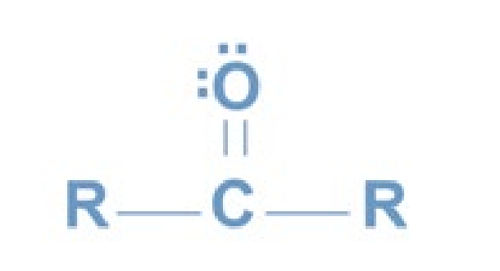

The homologous series of both aldehydes and ketones have the general formula, CnH2nO.

Aldehydes and ketones are present in many naturally occurring compounds. The aldehyde group is present in most sugars. They are the principal constituents of a number of essential oils used as fragrances and flavours. Ketonic group is present in camphor and menthone.

#### 12.2 NOMENCLATURE

##### a. Aldehydes

**Common Names:**

The common names of aldehydes are obtained from the common names of carboxylic acids containing the same number of carbon atoms. The ending -ic acid in the common name of the acid is replaced by the word aldehyde.

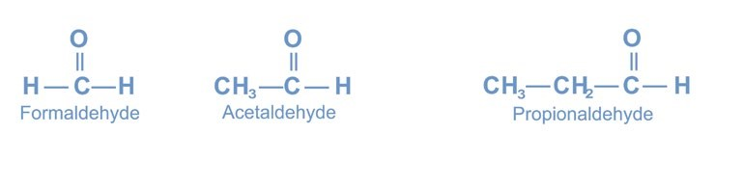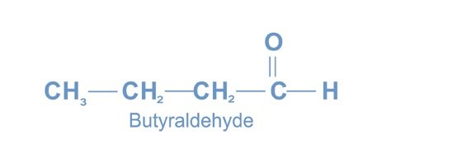

The positions of other groups on the chain are indicated by Greek letters

(a, b, g, d). Lettering starts on the carbon adjacent to the carbonyl group,

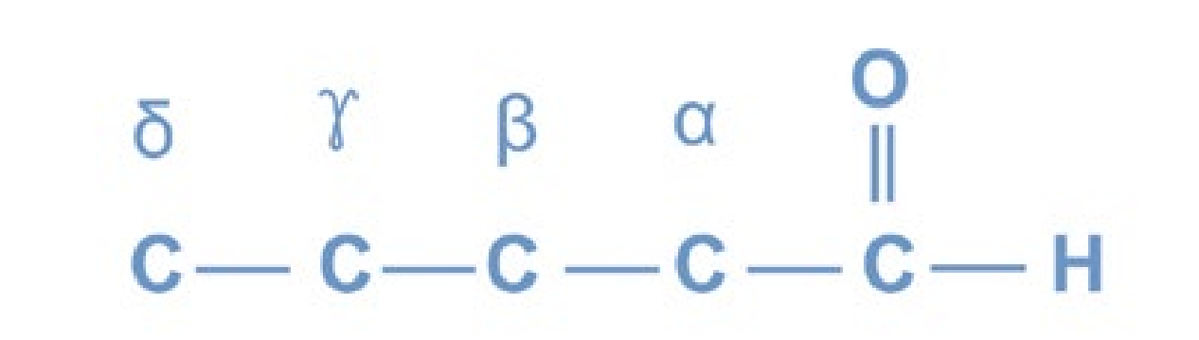

**IUPAC Names:**

|  |
| --- |
| 2 3 |

The **IUPAC** names of aldehydes are derived from the names of alkanes having the same number of carbon atoms. The letter - e in the name of the alkane is replaced with al The positions of other groups on the chain are indicated by using numbers. Numbering starts from the carbonyl carbon. Aromatic aldehydes are not given **IUPAC** names.

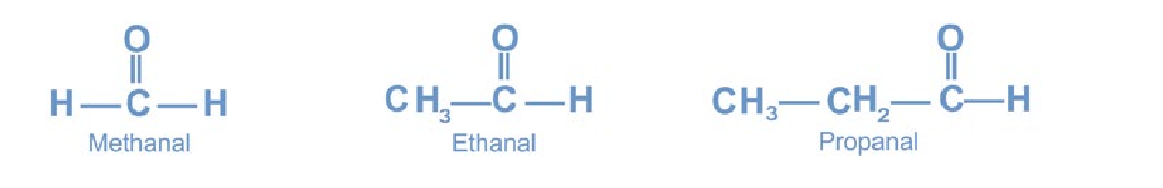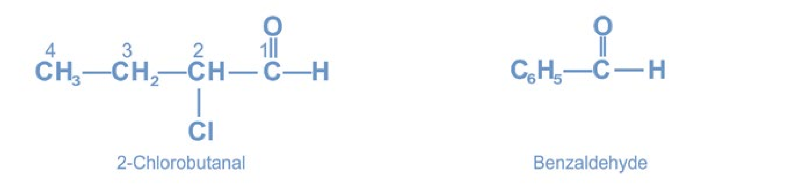

##### b. Ketones

###### Common Names

The common names of ketones are obtained by separately writing the names of the alky! groups attached to the carbonyl carbon. The word ketone is then added as a separate word. The names of the alkyl groups are written alphabetically. When the two alkyl groups are the same, the prefix di - is added before the name of the alkyl group.

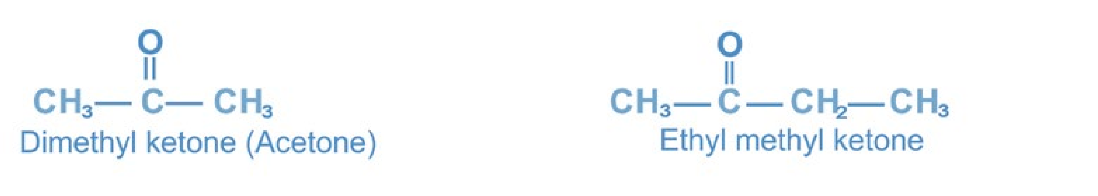

The positions of other groups are indicated by Greek letters, the a - carbon atom being the one adjacent to the carbonyl group. If the two alkyl groups in a ketone are the same, the ketone is said to be symmetrical, if unlike, unsymmetrical.

###### IUPAC Names

The IUPAC names of ketones are derived from the names of alkanes having the same number of carbon atoms. The letter e in the name of alkane is replaced with the suffix -one. The positions of the carbonyl group and of other groups on the chain are indicated by numbers. Numbering is started from that end whjch is nearest to the carbonyl group. Aromatic ketones are not given IUPAC names.

#### 12.3 PREPARATION OF ALDEHYDES AND KETONES

Aldehydes are obtained by the oxidation of primary alcohols whereas ketones by the oxidation of secondary alcohols. Ketones are also prepared by hydration of alkynes.

##### a. Preparation of Formaldehyde (Formalin) (i) Laboratory Method

Formaldehyde is prepared in the laboratory by passing a mixture of methyl alcohol vapours and air over platinised asbestos or copper or silver catalyst at 300 0C.

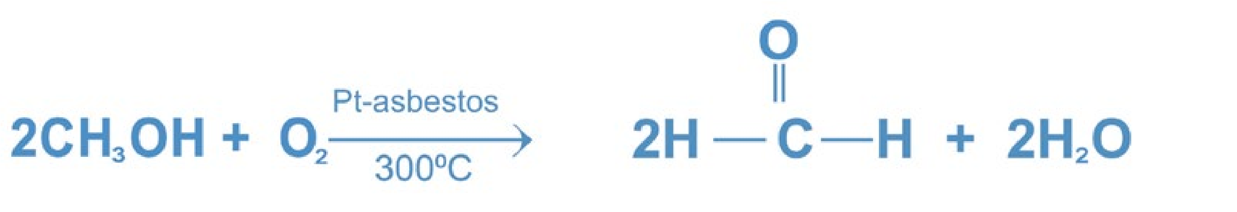

|  |
| --- |
| 4 5 |

Set up the apparatus as shown in Fig. (12.1). Air is drawn through methyl alcohol with the help of a suction pump. Methyl alcohol is oxidised to gaseous formaldehyde which is absorbed in water. The resulting mixture is called formalin. Formalin is a mixture of 40 % formaldehyde, 8% methyl alcohol and 52 % water.

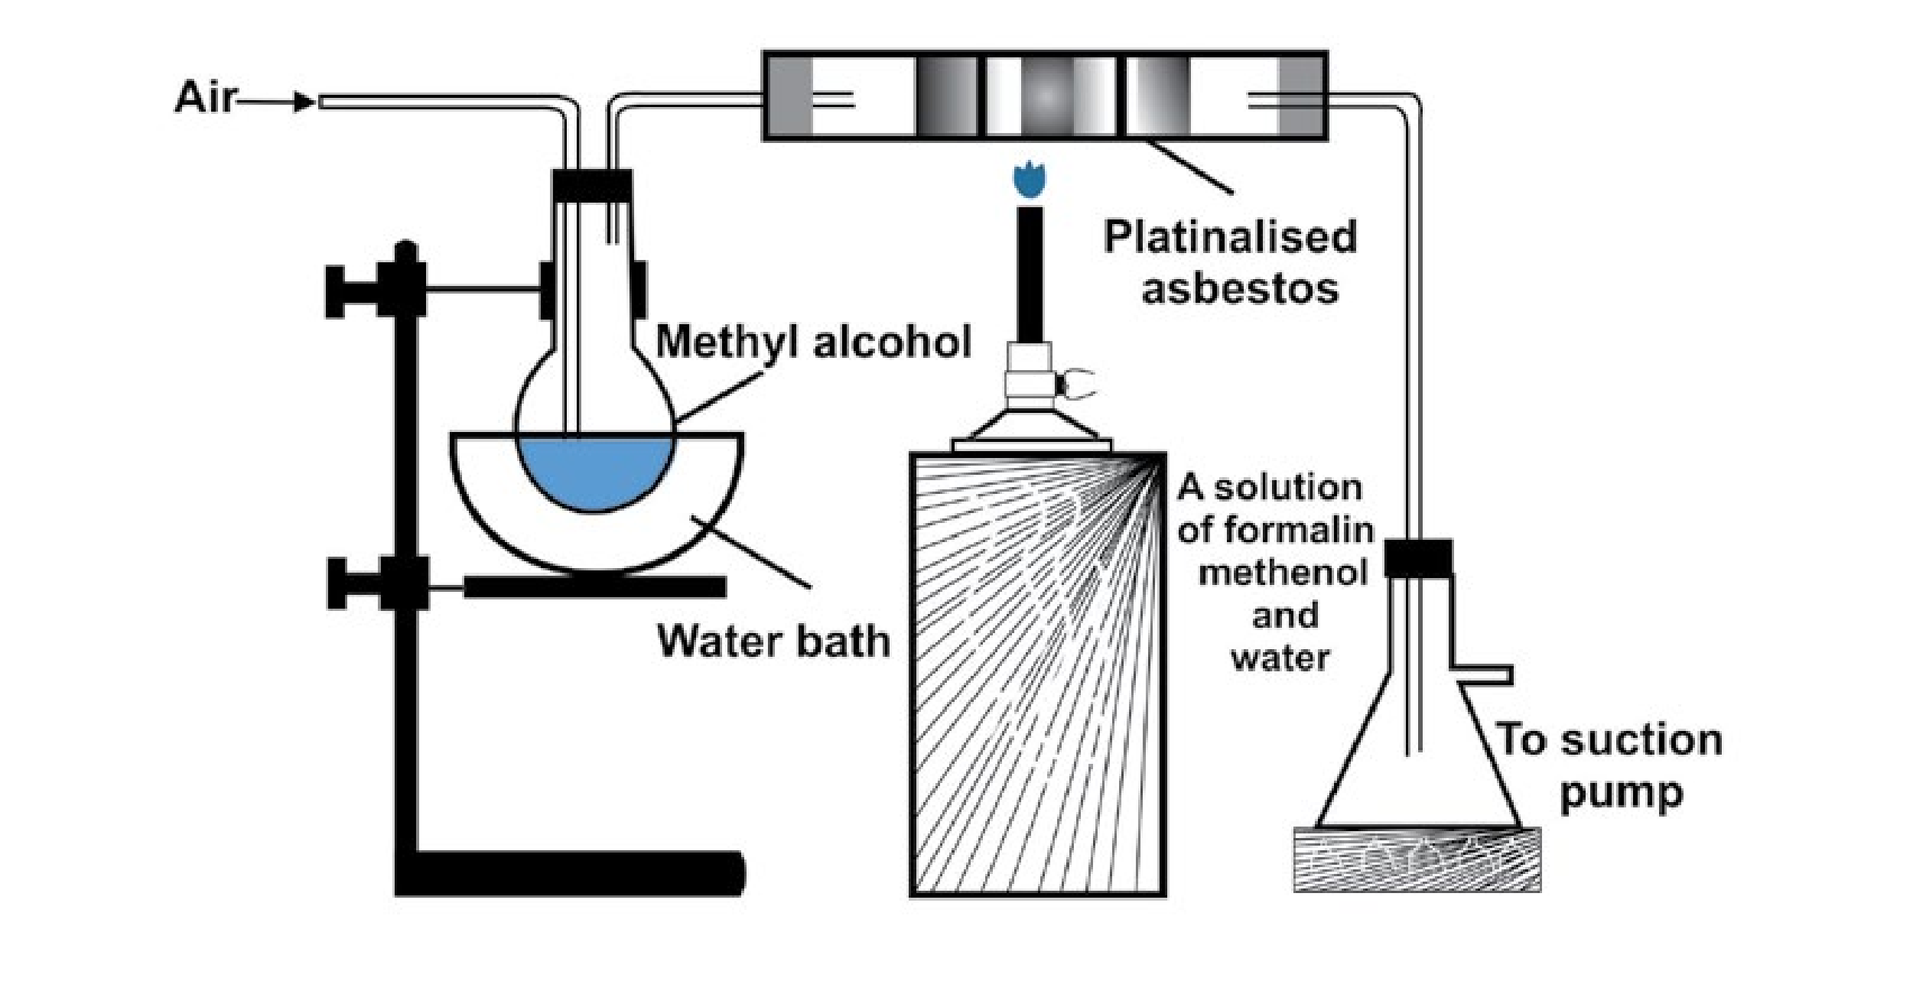

**methanol**

*Fig. 12.1 Preparation of Formaldehyde (formalin)*

##### (ii) Industrial Method

Formaldehyde is manufactured by passing a mixture of methanol vapours and air over iron oxide-molybdenum oxide or silver catalyst at 500 °C.

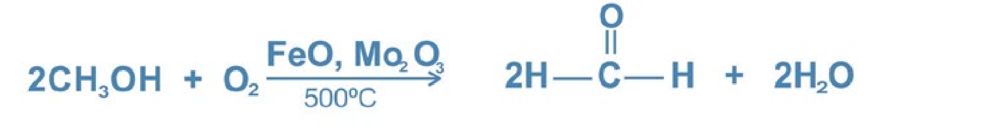

**b. Preparation of Acetaldehyde (i) Laboratory method**

Acetaldehyde is prepared in the laboratory by the oxidation of ethyl alcohol with acidified sodium dichromate solution.

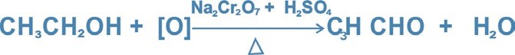

*Fig. 12.2 Preparation of Acetaldehyde*

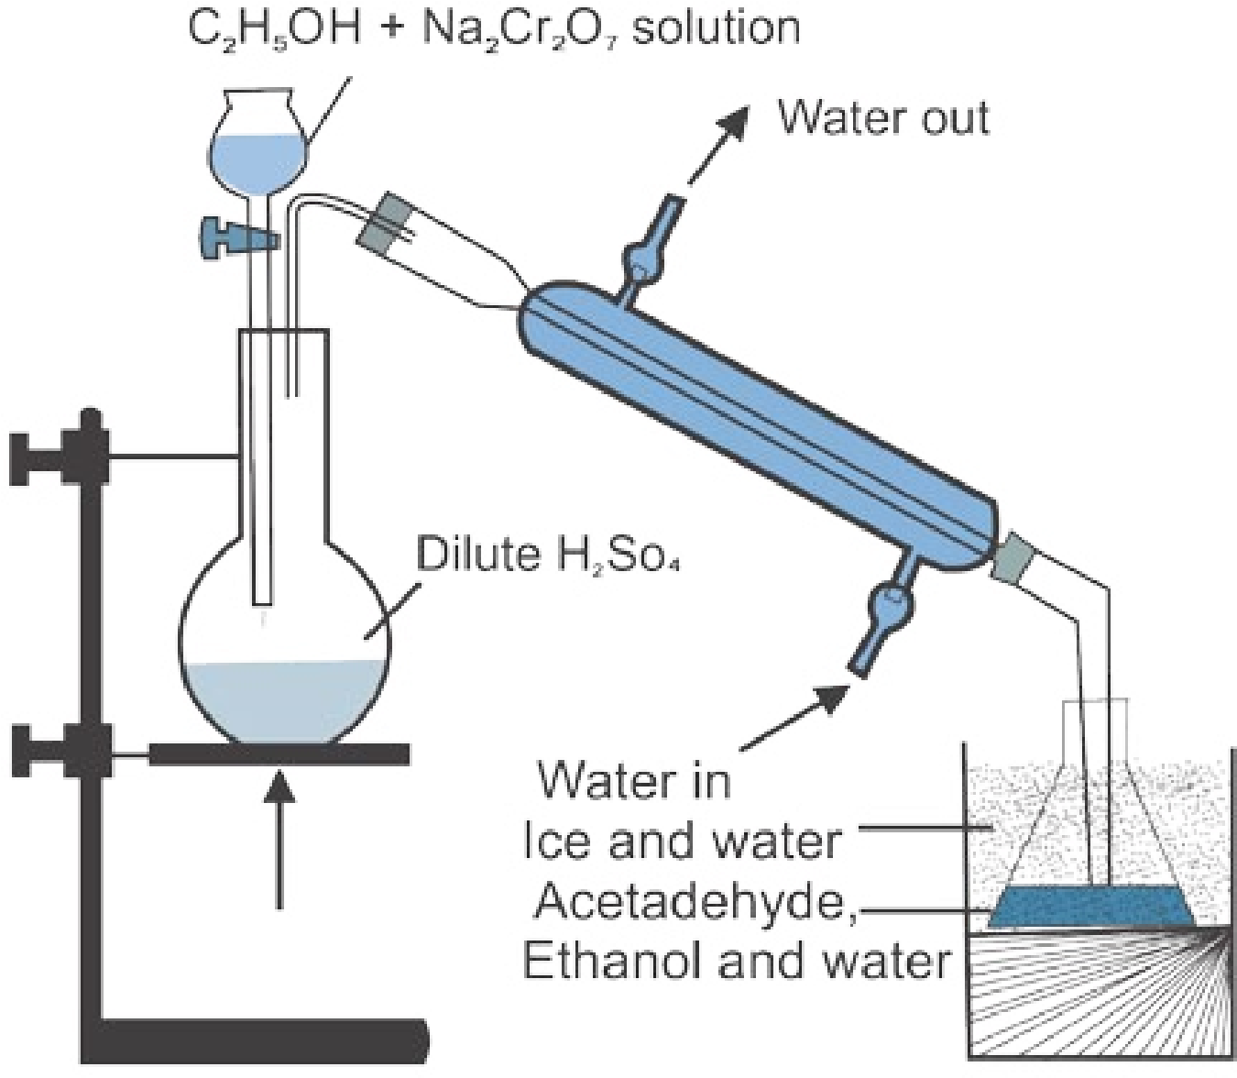

A mixture of ethyl alcohol and sodium dichromate solution is run into boiling dilute sulphuric acid. Immediately a vigorous reaction takes place and the acetaldehyde formed in liquid state is immediately distilled off. This prevents the oxidation of acetaldyde to acetic acid. Ethyl alcohol remains in solution until it is oxidised. Pure acetaldehyde is obtained by redistillation.

Acetaldehyde can also be prepared by the dry distillation of a mixture of calcium salts of formic acid and acetic acid.

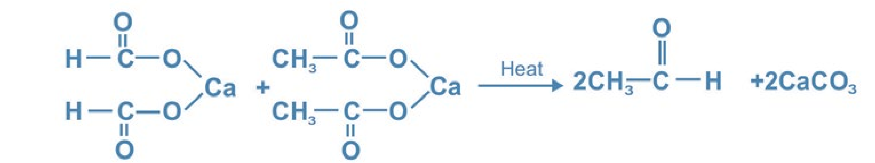

##### (ii) Industrial Method

|  |
| --- |
| 6 7 |

Acetaldehyde is prepared industrially by air oxidation of ethylene using palladium chloride catalyst with a cupric chloride promoter.

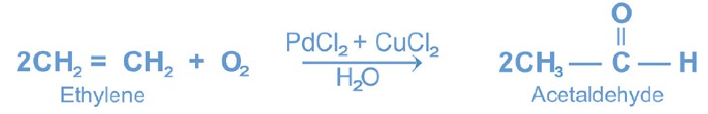

##### C. Preparation of Acetone

Acetone is prepared by dry distillation of calcium acetate.

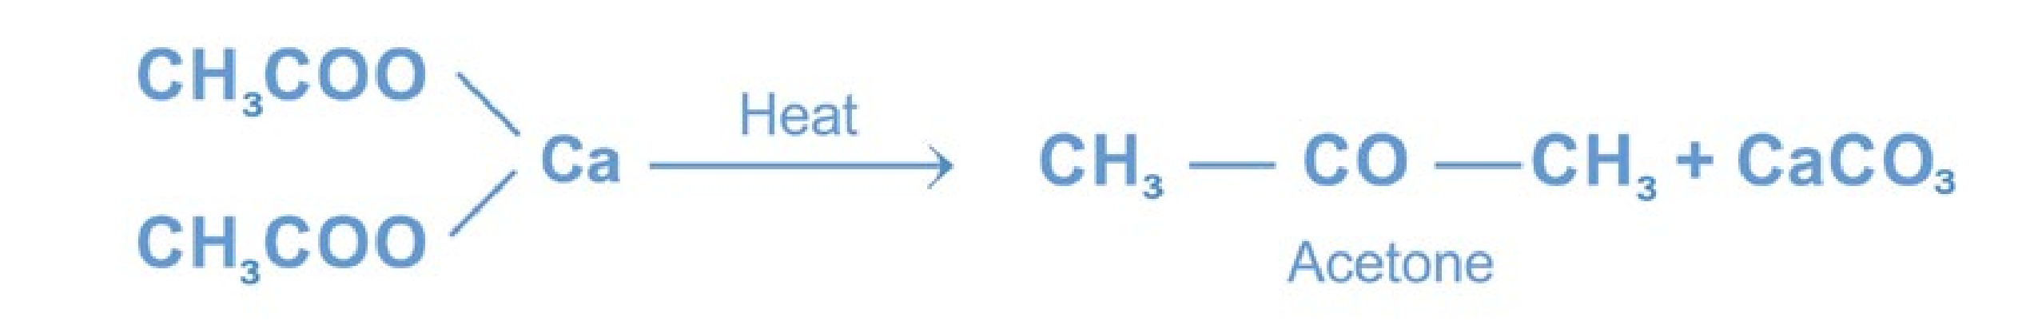

#### 12.4 REACTIVITY OF CARBONYL GROUP

The carbonyl group has a s-bond and a p-bond. Thus it can undergo addition reactions. Most reagents react with the carbonyl group by adding to it. As oxygen is more electronegative, it tends to attract the p electrons to itself. This attraction makes the carbonyl group a polar group. The oxygen atom has a partial negative charge on it and is nucleophilic, whereas the carbon atom has a partial positive charge and is electrophilic,

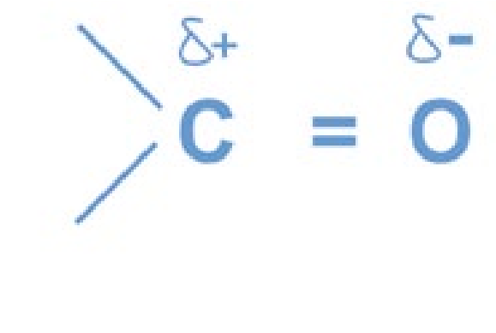

##### Nucleophilic Addition Reactions of Aldehydes and Ketones

As a result of the unsymmetrical electronic distribution about the carbonyl group, the nucleophilic reagent can start the initial attack on the carbon. It appears that whether the initial attack is to be by a nucleophilic reagent or by an electrophilic reagent depends upon a particular reaction and upon the conditions under which that reaction is carried out. Therefore, most of the reactions of the carbonyl group will be considered to be nucleophilic addition reactions.

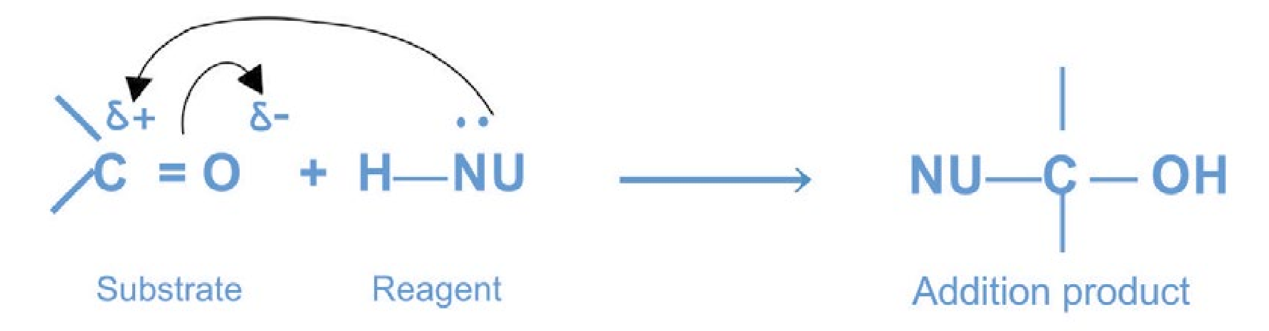

In these reactions of aldehydes and ketones, the negative part of the reagent combines with the electrophilic carbon of the carbonyl group, whereas the positive part, which is usually hydrogen goes to the oxygen. The nucleophilic addition reactions of carbonyl group are catalysed by bases or acids. Remember that whether the addition is base-catalysed or acid-catalysed, the adduct is the same. A base catalyst increases the nucleophilic character of the reagent, while an acid-catalyst promotes the nucleophilic attack by increasing the positive character (electrophilic character) of the carbonyl carbon atom.

#### 12.5 REACTIONS OF CARBONYL COMPOUNDS

##### 12.5.1 Nucleophilic Addition Reactions

The characteristic reactions of carbonyl compounds are nucleophilic addition reactions.

###### (a) Base-Catalysed Addition Reactions

A base-catalysed nucleophilic addition reaction will take place with a strong nucleophilic reagent. The base reacts with the reagent and generates the nucleophile. The addition is initiated by the attack of a nucleophile on the electrophilic carbon of the carbonyl group. The general mechanism of the reaction is as follows:

8 9

**General mechanism:**

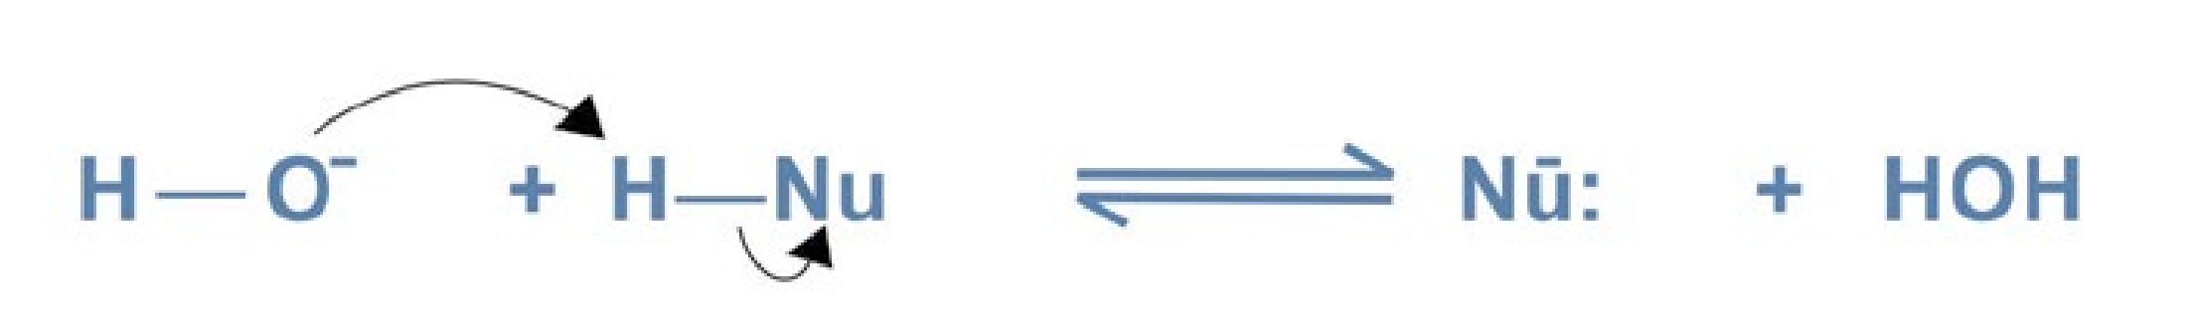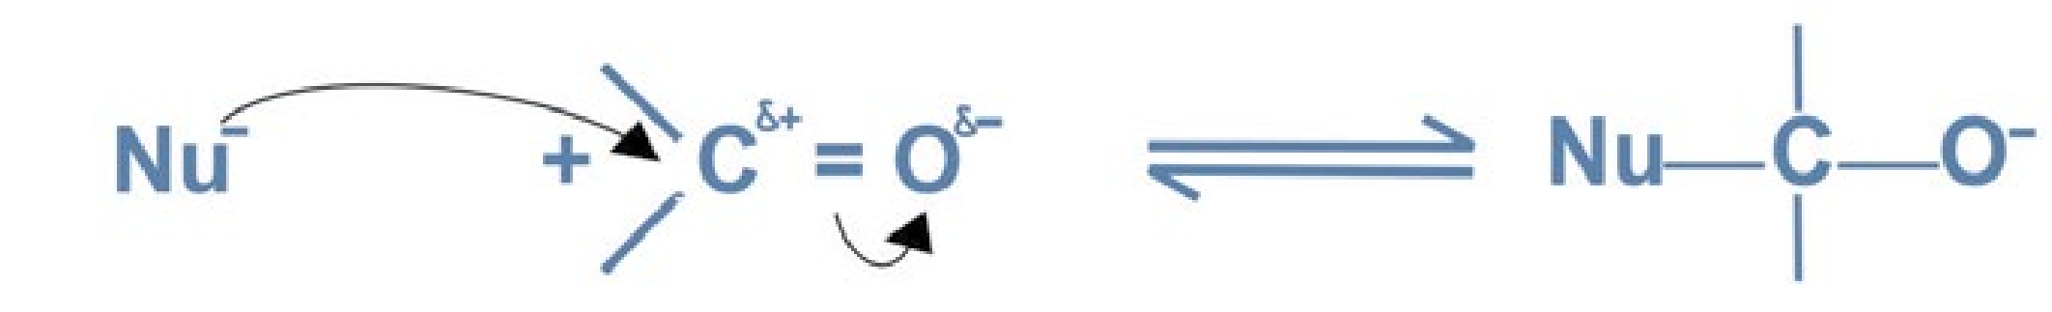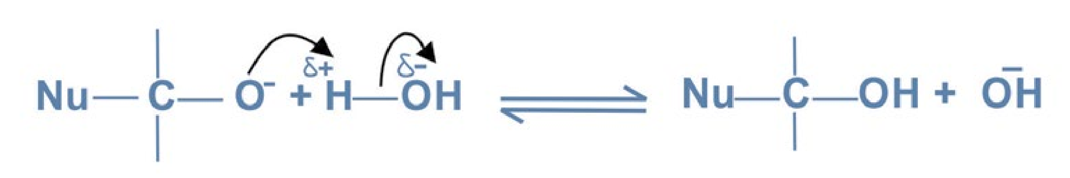

The base-catalysed nucleophilic addition reactions of aldehydes and ketones are the following:

1. Addition of Hydrogen Cyanide

Hydrogen cyanide adds to aldehydes and ketones to form cyanohydrins. The reaction is carried out by adding slowly a mineral acid to an aqueous solution of sodium cyanide. The acid generates HCN from sodium cyanide *in situ.*

10

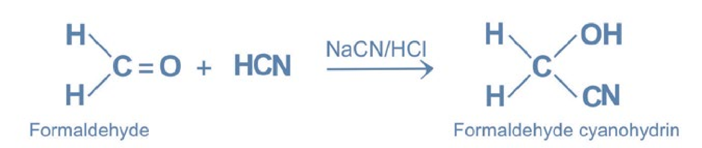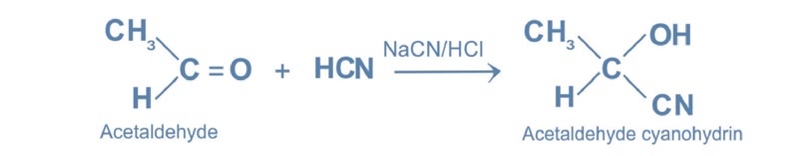

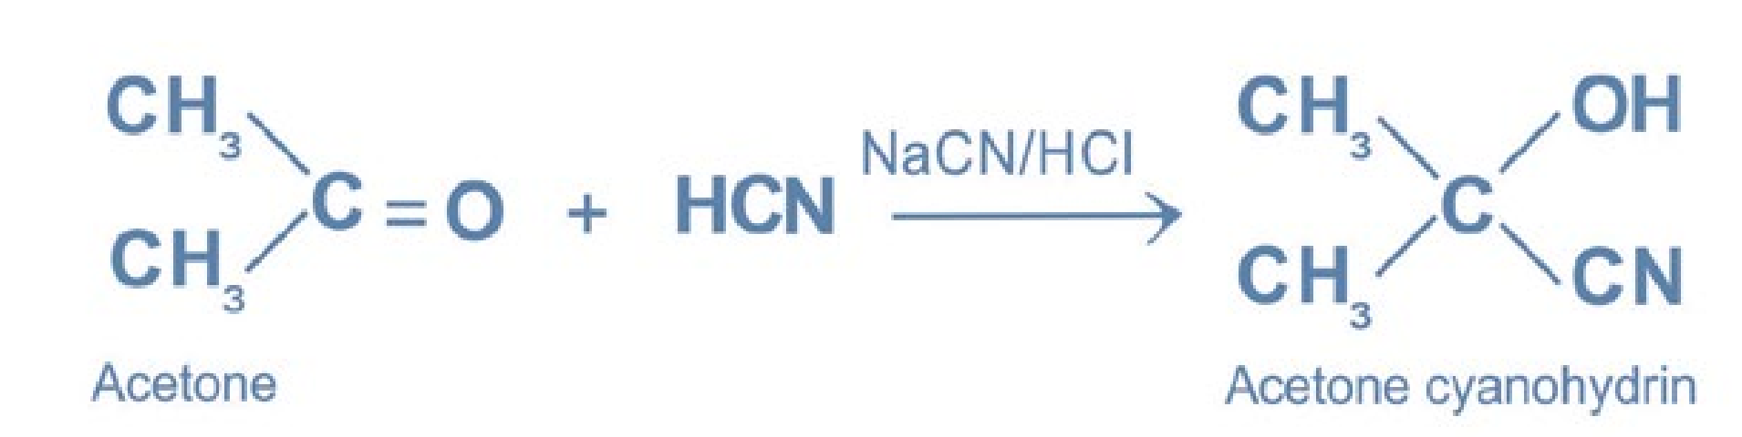

The cyano group, — C ≡ N is hydrolysed by an aqueous acid into a carboxylic acid through an acid amide.

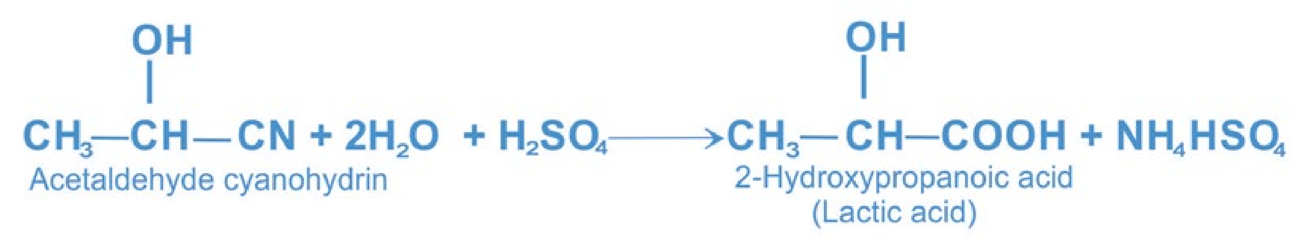

The reaction is used in the synthesis of a-hydroxy acids that contain one carbon atom more than the number of carbon atoms in the starting aldehydes or ketones.

**Mechanism:**

Nucleophilic attack by the negatiely charged carbon of cyanide ion at the carbonyl carbon of the aldehyde and ketone. Hydrogen cyanide itself is not very nucleophilic and does not ionize to from cyanide to a significant extent. Thus , a source of cyanide ion such as NaCN or KCN is used.

The mechanism of the reaction is as follows:

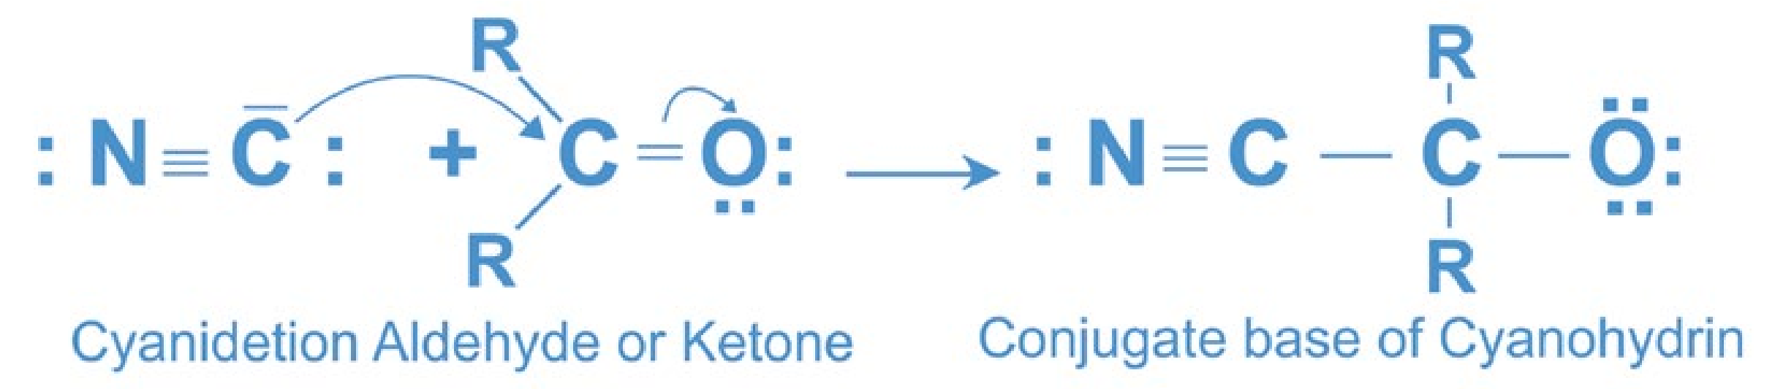

Cyanide ion

11

The

hydroxide

ion

liberated

in

the

formation

of

cyanohydrin

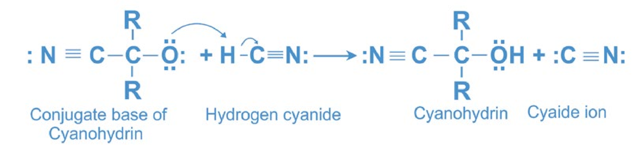

Cyanide ion

reacts with undissociated hydrogen cyanide and produces more cyanide ions, which in turn react with more carbonyl compound.

2. Addition of Grignard Reagents

Grignard reagents add to aldehydes and ketones to form adducts which on hydrolysis with a dilute mineral acid (HCI, H2SO4) give alcohols. The reaction has already been studied in chapter 10.

3. Addition of Sodium Bisulphite

Aldehydes and small methyl ketones react with a saturated aqueous solution of sodium bisulphite to form a crystalline white precipitate of sodium bisulphite adduct.

12

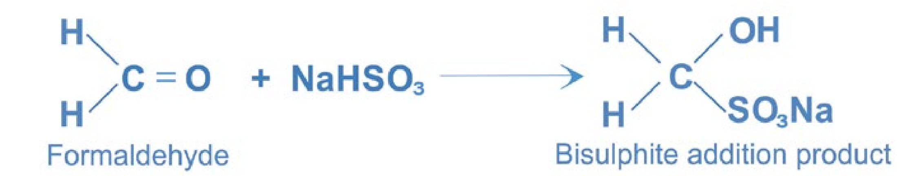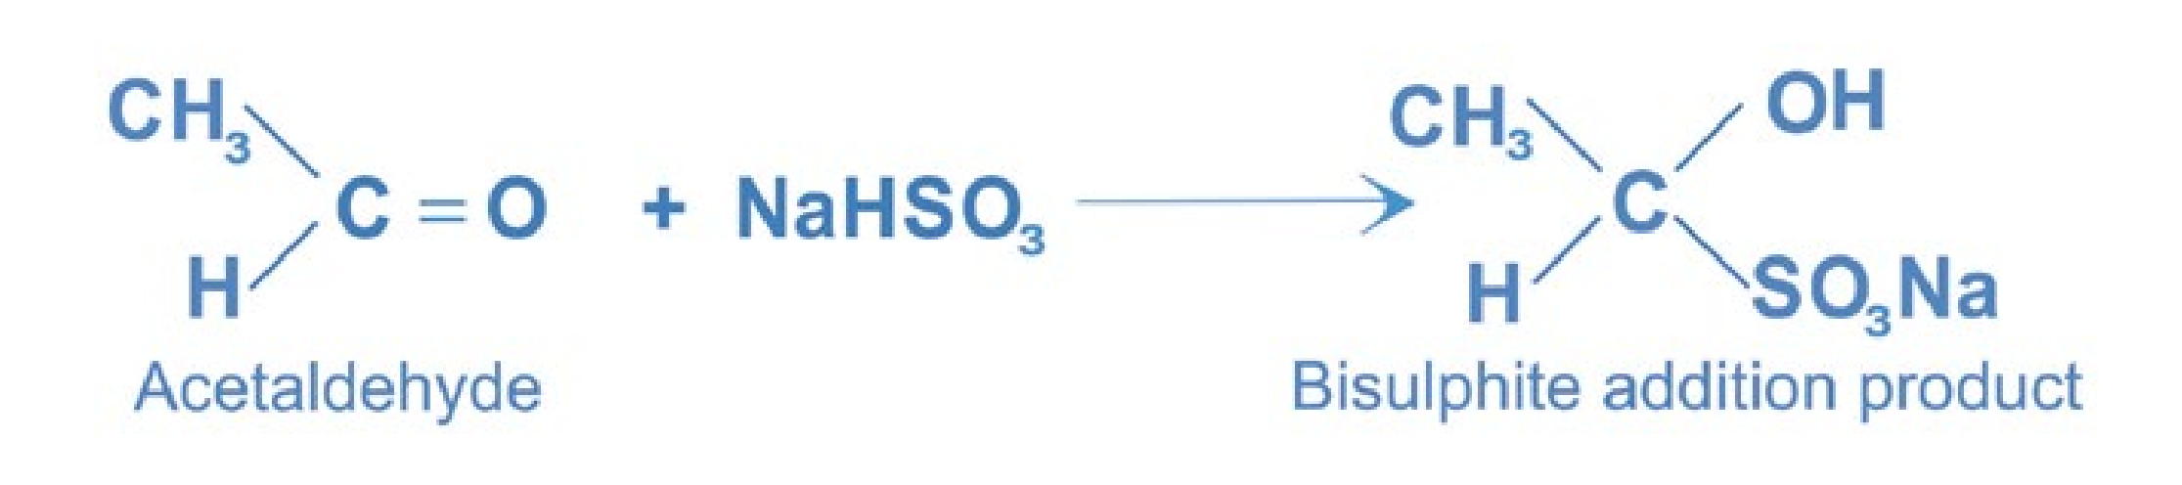

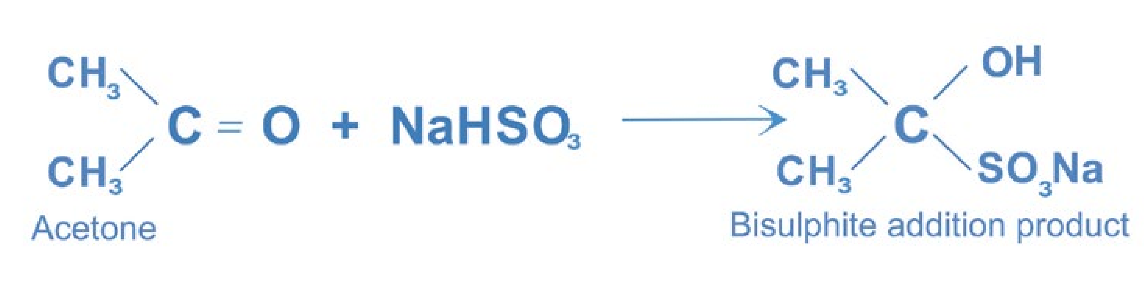

Bisulphite on heating with a dilute mineral acid (HCl or H2SO4), regenerates the parent aldehyde or ketone.

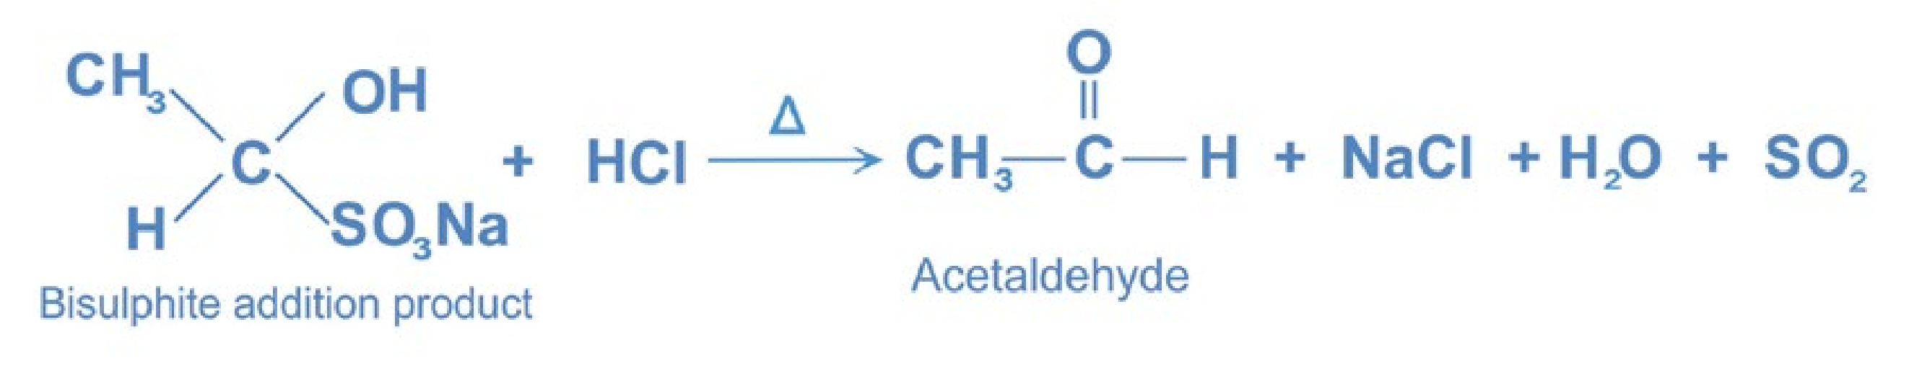

The reaction is used for the separation and purification of carbonyl compounds from non-carbonyl compounds such as alcohols.

**Mechanism:**

Sodium bisulphite ionises to form sulphite ions.



The sulphite ion acts as a nucleophile, since the sulphur atom is more nucleophilic than oxygen, a C—S bond is formed.

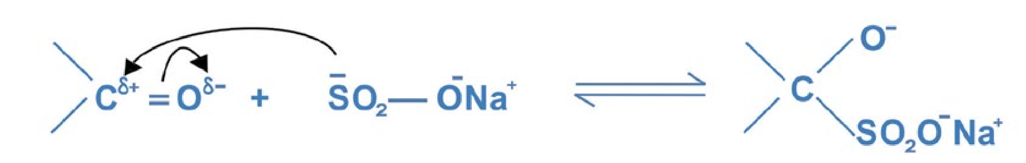

Proton is attached to the negatively charged oxygen atom to form bisulphite addition product.

13

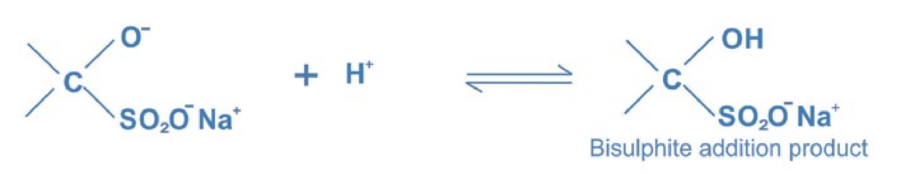

Ketones in which both alkyl groups are larger than methyl do not react with sodium bisulphite.

4. Condensation Reactions

The reactions in which two molecules of the same or different compounds combine to form a new compound with or without the elimination of a small molecule like H2O or NH3, are called condensation reactions.

###### (i) Aldol Condensation

Aldehydes and ketones possessing a-hydrogen atoms react with a cold dilute solution of an alkali to form addition products known as aldols. The name ‘aldol’ is given to the product because it contains both aldehyde and alcohol functional groups. Note that the name aldol condensation is reserved for the reaction that starts with two identical carbonyl compounds. Two molecules of the same carbonyl compound condense to form an aldol.

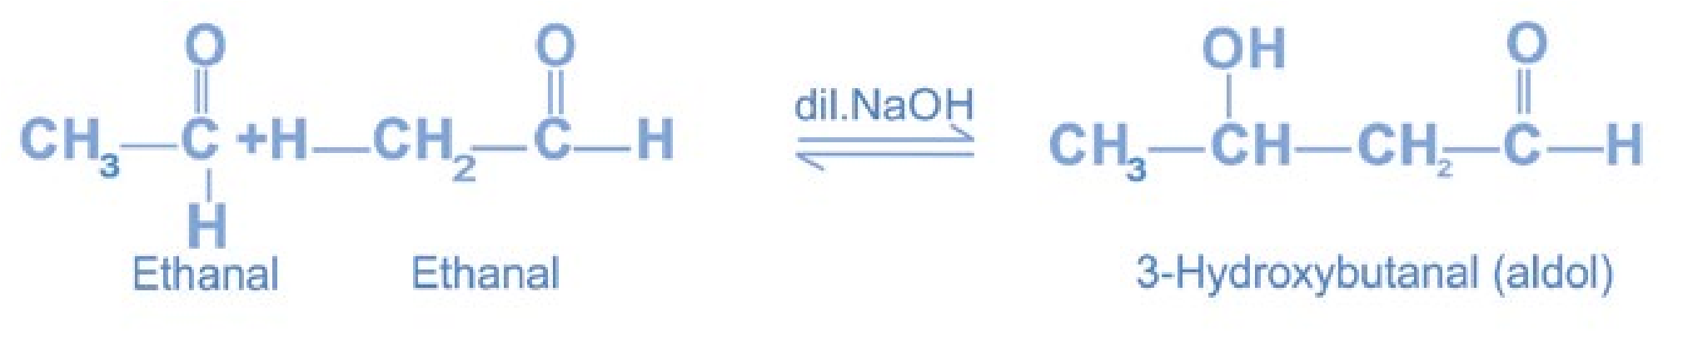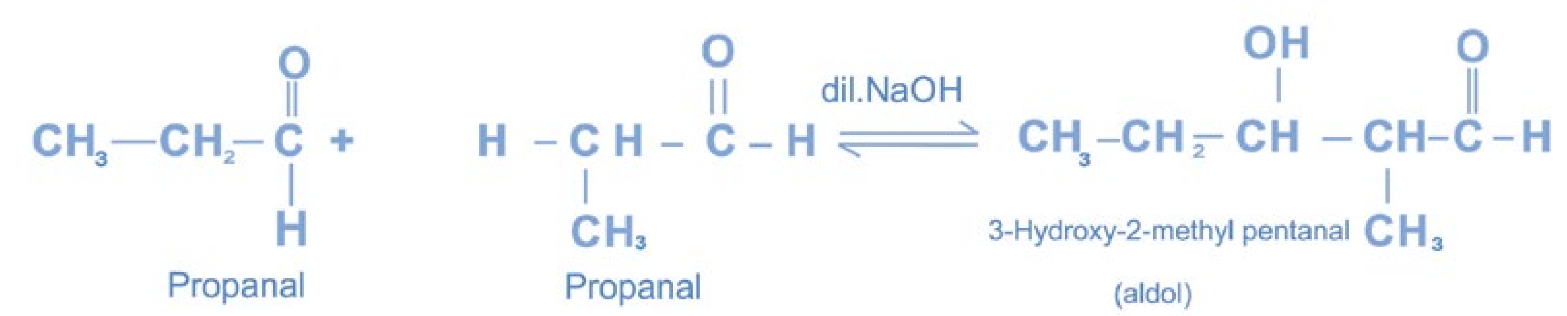

14

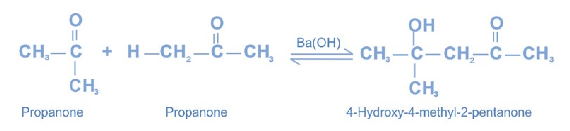

The aldol compound readily loses water on heating in the presence of dilute acid to form an unsaturated carbonyl compound. A carboncarbon double bond is formed between the a- and b- carbon atoms.

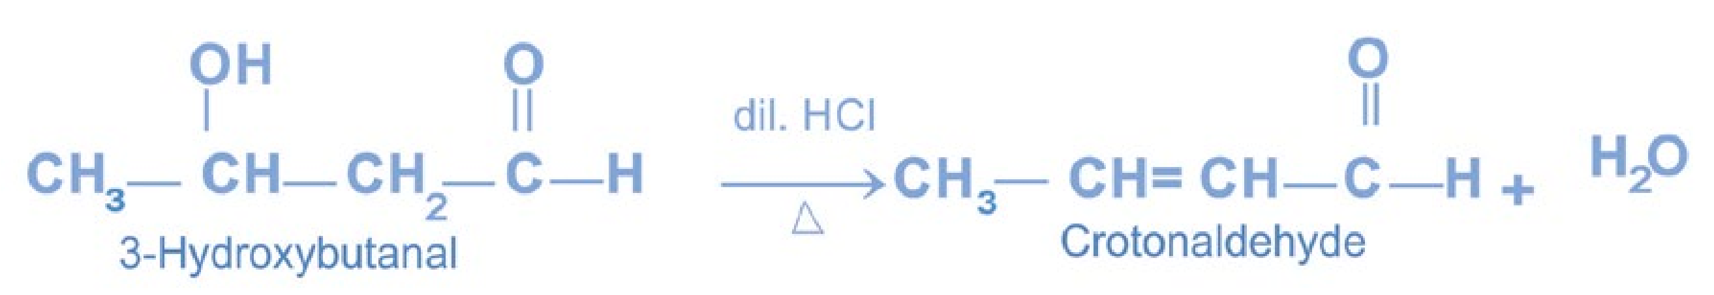

**Mechanism of Aldol Condensation:**

The hydroxide ion acts as a base. It removes a proton from a-carbon of one molecule of the carbonyl compound to form a carbanion.

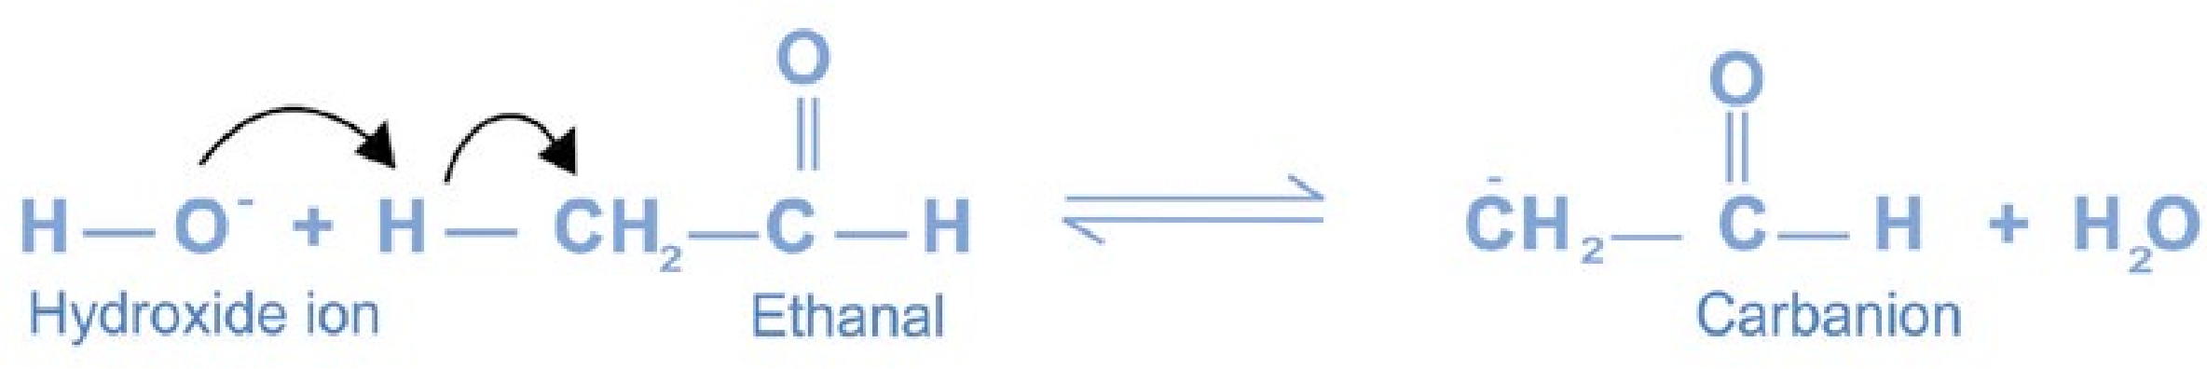

The carbanion acts as a nucleophile. It attacks the electrophilic carbonyl carbon atom of the unchanged second molecule to form an alkoxide ion.

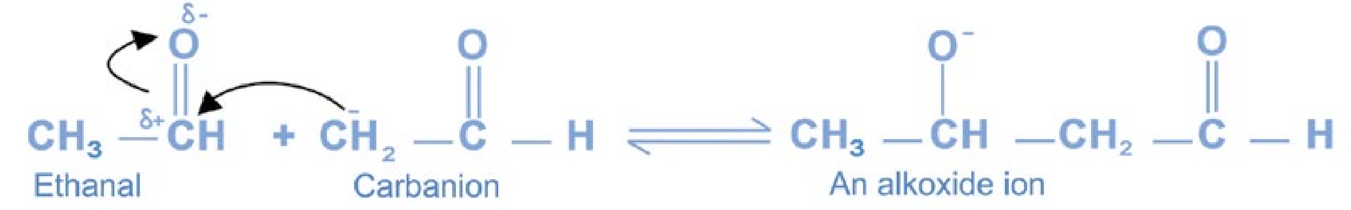

The alkoxide ion removes a proton from water to form aldol.

15

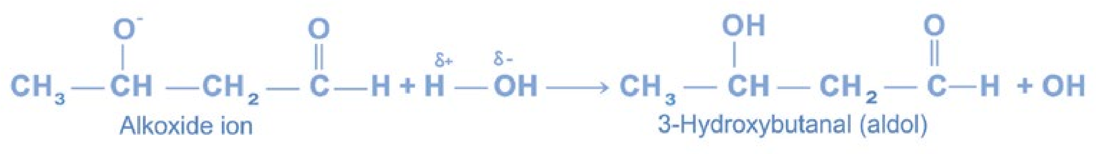

The basic catalyst hydroxide ion is regenerated.

5. Cannizzaro’s Reaction

Aldehydes that have no a-hydrogen atoms undergo Cannizzaro’s reaction. It is a disproportionation (self oxidation-reduction) reaction. Two molecules of the aldehyde are involved, one molecule being converted into the corresponding alcohol (the reduced product) and the other into the acid in the salt form (the oxidation product). The reaction is carried out with 50 percent aqueous solution of sodium hydroxide at room temperature.

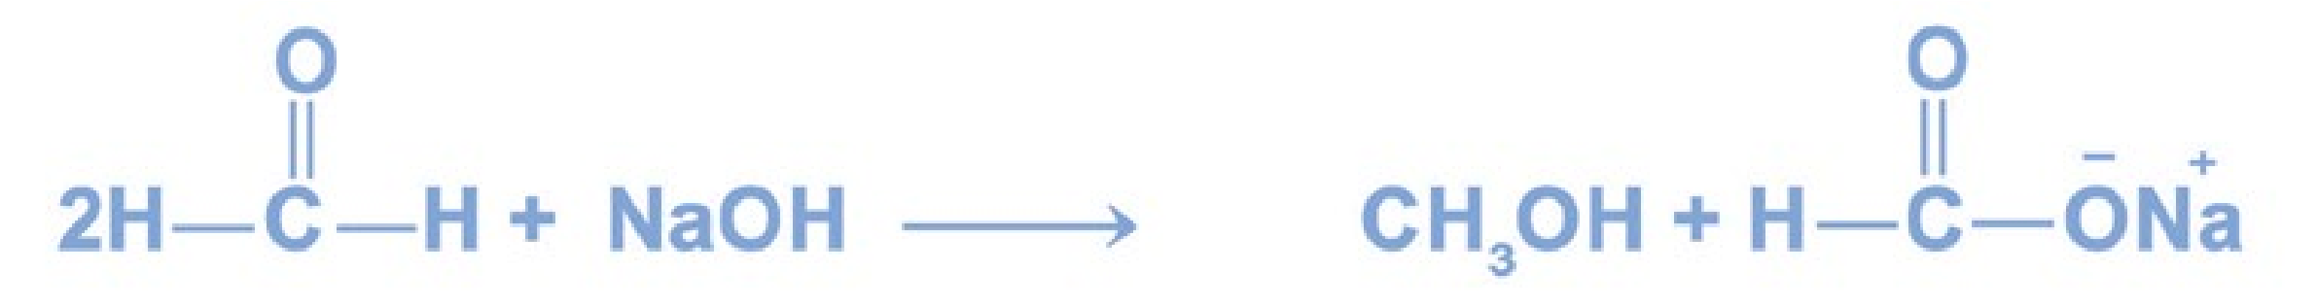

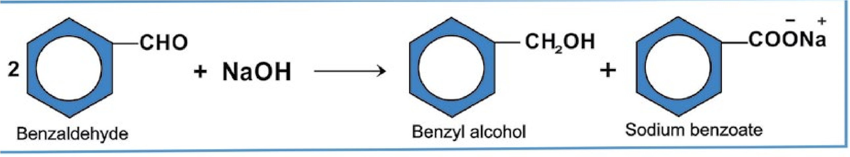

**Mechanism:**

The

hydroxide

ion

acts

as

a

nucleophile.

It

attacks

on

the

16

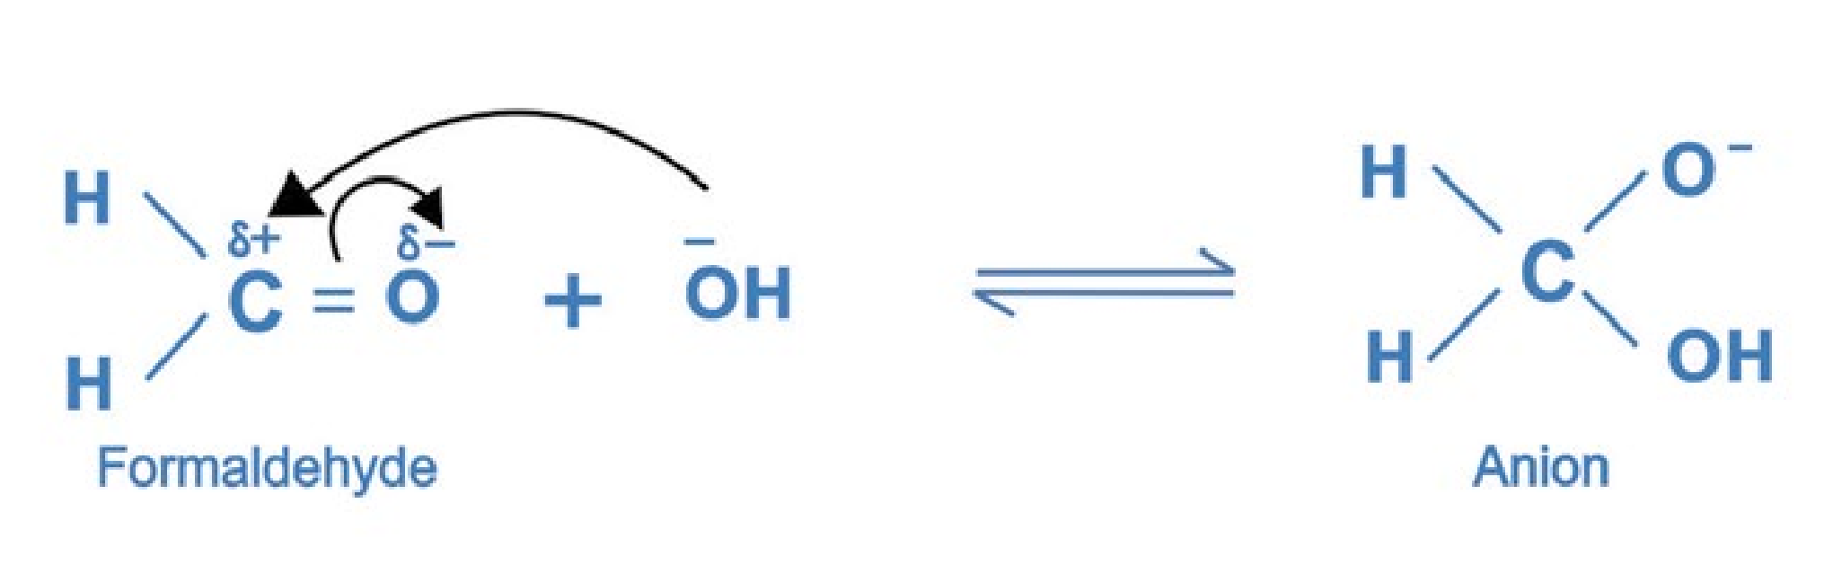

electrophilic

carbonyl

carbon

to

form

a

complex

anion.

The anion transfers a hydride ion to second molecule of formaldehyde.

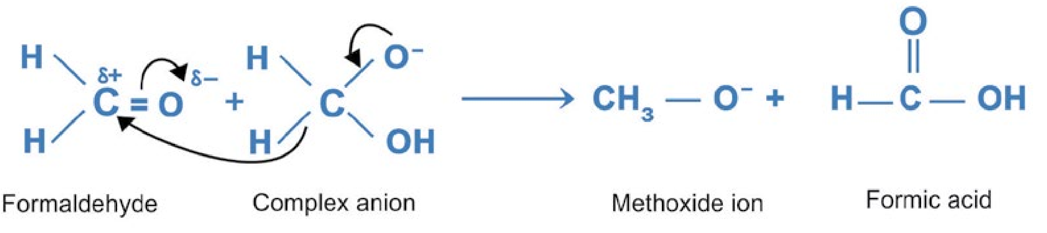

The presence of the negative charge on oxygen of the anion helps in the loss of hydride ion.The methoxide ion acts as a base and abstacts a proton from formic acid to form methanol and formate ion.

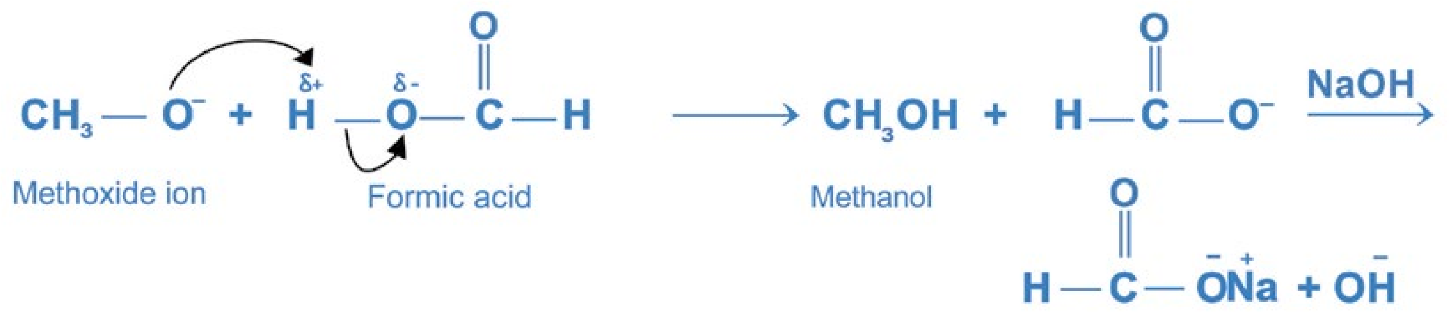

The formate ion in the presence of alkali gives a salt of the acid.

6. Haloform Reaction

Only acetaldehyde and methyl ketones react with halogens in the presence of sodium hydroxide to give haloform and sodium salt of the acid. The term haloform is used for the reaction because a haloform (chloroform, bromoform or iodoform) is one of the products.

17

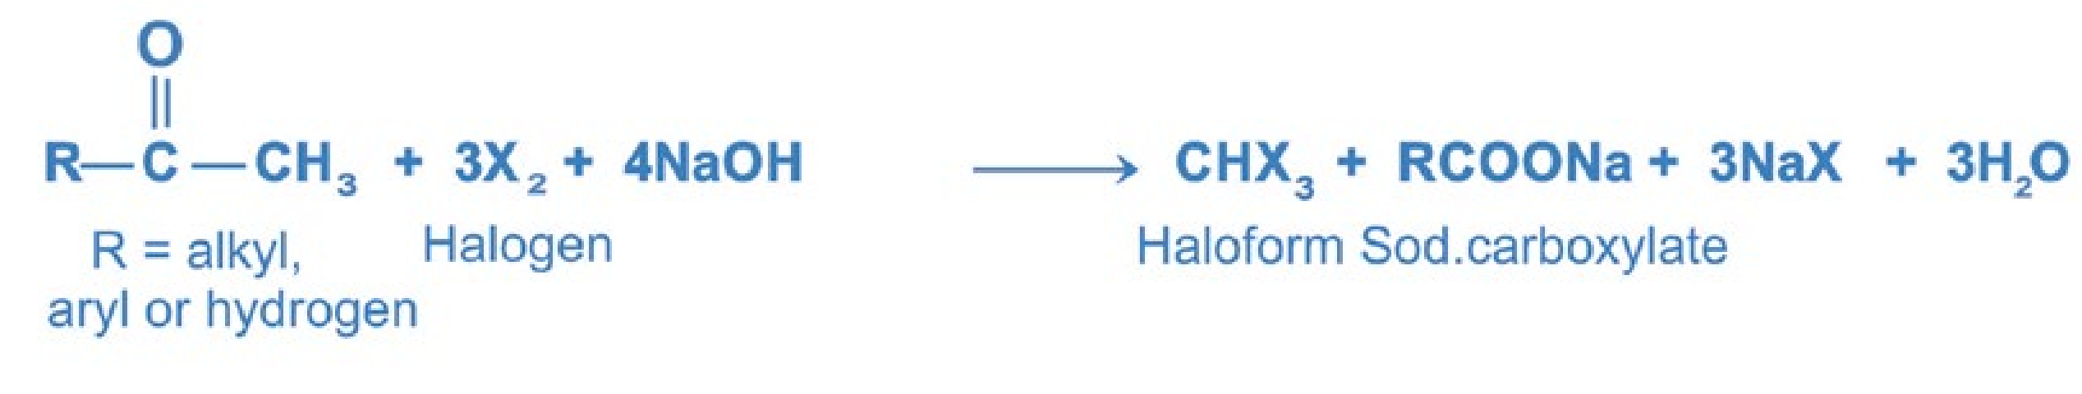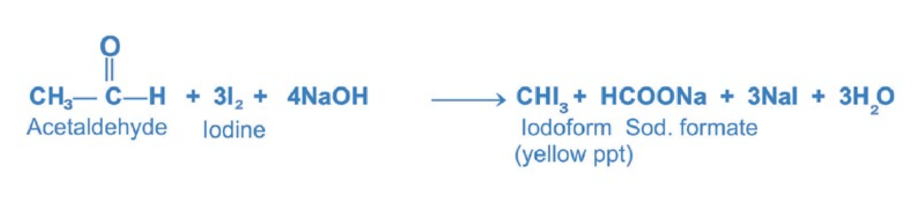

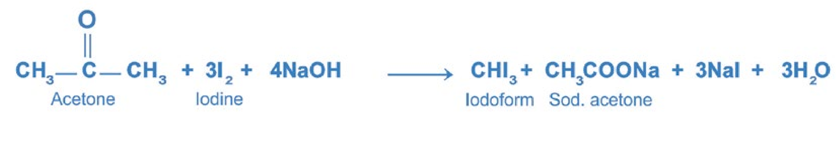

Secondary alcohols containing the hydroxyl group on the second carbon atom also undergo this reaction. Ethanol is the only primary alcohol that gives this reaction.

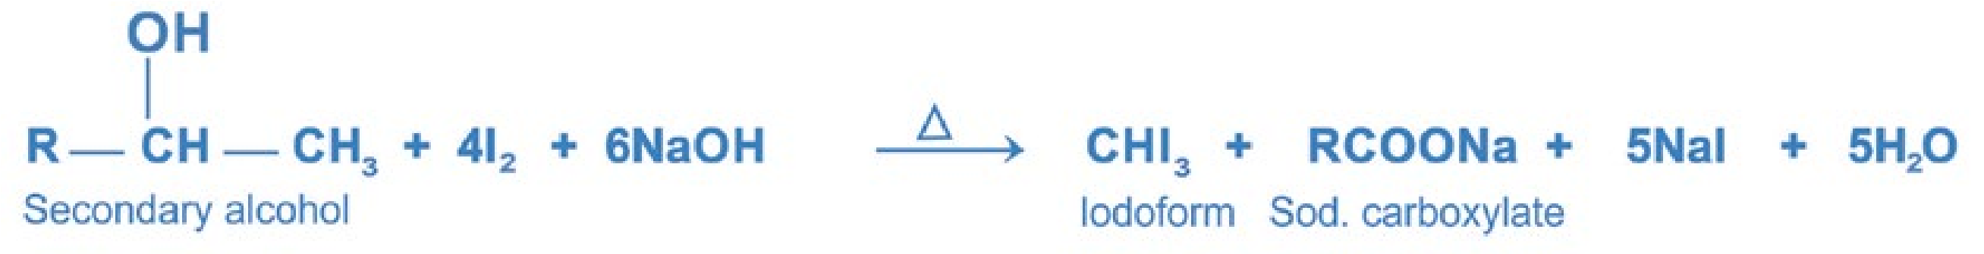

From a synthetic point of view the haloform reaction affords a convenient method for converting a methyl ketone to a carboxylic acid containing one carbon atom less than the parent compound. **Iodoform Test:**

The haloform reaction using iodine and aqueous sodium hydroxide is called the iodoform test. It results in the formation of water insoluble iodoform which is a yellow solid. Iodoform test is used for distinguishing methyl ketones from other ketones. It is also used to distinguish ethanol from methanol and other primary alcohols. It can be used to distinguish acetaldehyde from other aldehydes.

###### (b) Acid-Catalysed Addition Reactions

The acid catalysed nucleophilic addition reaction will take place with a weak nucleophilic reagent. The addition is initiated by the proton (H+) liberated by the acid. The proton combines with the carbonyl oxygen atom and increases the electrophilic character of the carbonyl carbon. As a result, the attack of the weaker nucleophile on the electrophilic carbon becomes easier.

18

The general mechanism of the reaction is as follows.

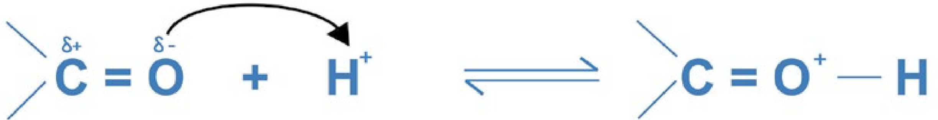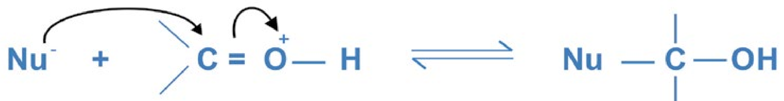

The acid- catalysed nucleophilic addition reactions of aldehydes and ketones are the following.

**1.** Both formaldehyde and acetaldehyde polymerize in the presence of dil. H2SO4 to give metaformaldehyde and paraldehyde respectively.

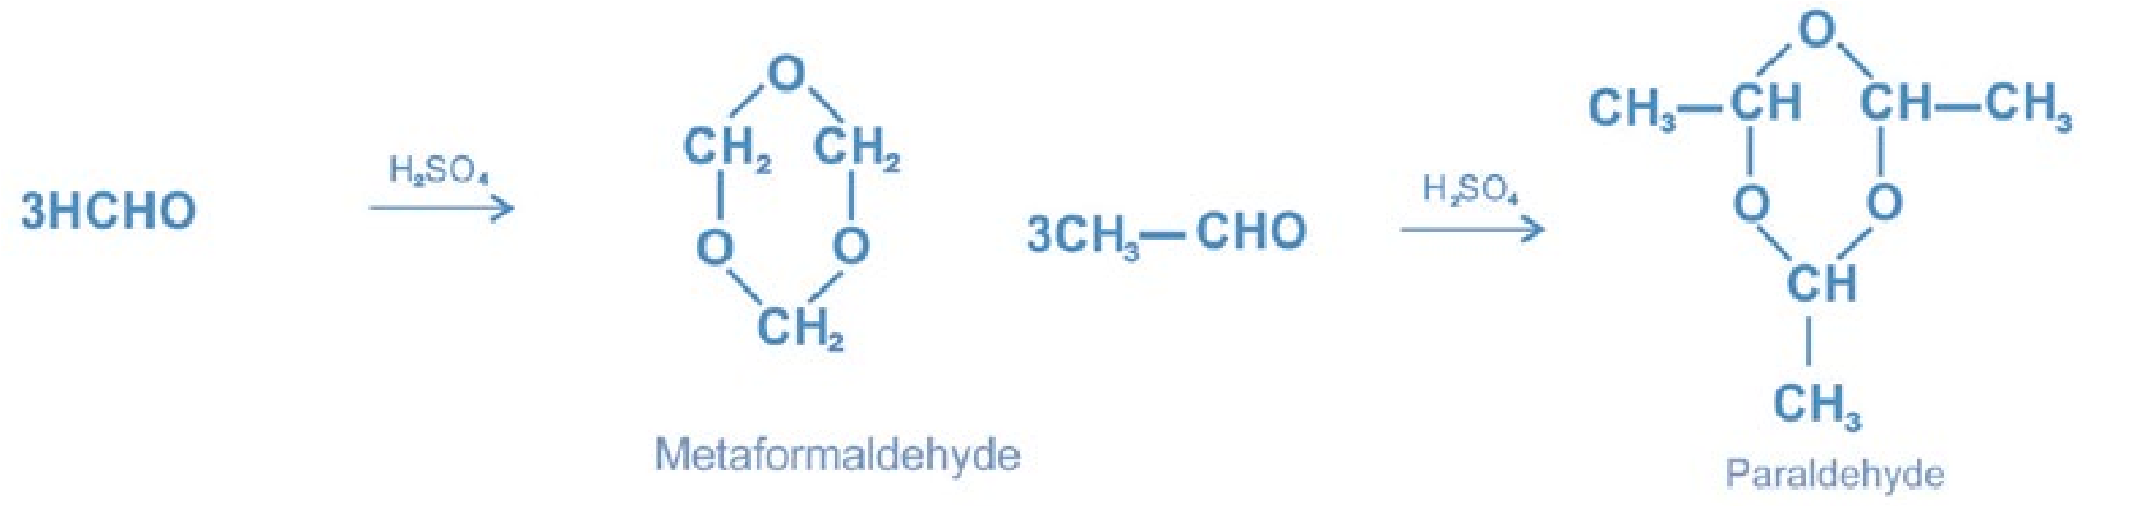

2. Reactions of Ammonia Derivatives

Aldehydes and ketones react with ammonia derivatives, G — NH2 to form compounds containing the group, and water. C = N— G The reaction is known as condensation reaction or addition - elimination reaction because water is lost after addition occurs. The reaction is acid catalysed.

The general reaction is:

19

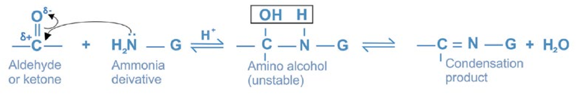

Where etc. G = OH, — NH2, — NHC6H5, —NHCONH2,

Some commonly used ammonia derivatives are hydroxylamine, NH2OH, hydrazine, NH2NH2, phenylhydrazine, C6H5NHNH2, semicarbazide, NH2NHCONH2, and 2,4- dinitrophenylhydrazine, NH2NHC6H3(NO2)2.

The reactions of the above stated ammonia derivatives with aldehydes and ketones are as follow.

###### (i) Reaction with Hydroxylamine

Aldehydes and ketones react with hydroxylamine to form oximes in the presence of an acid.

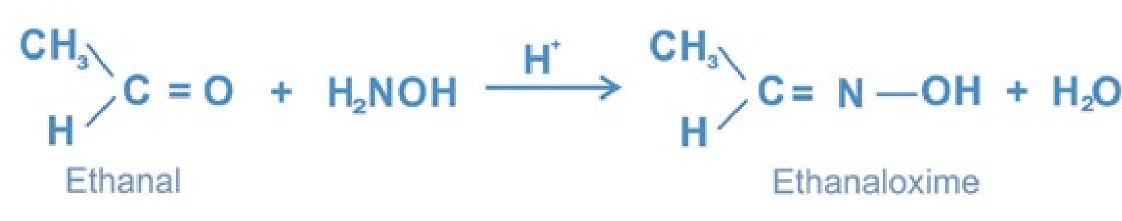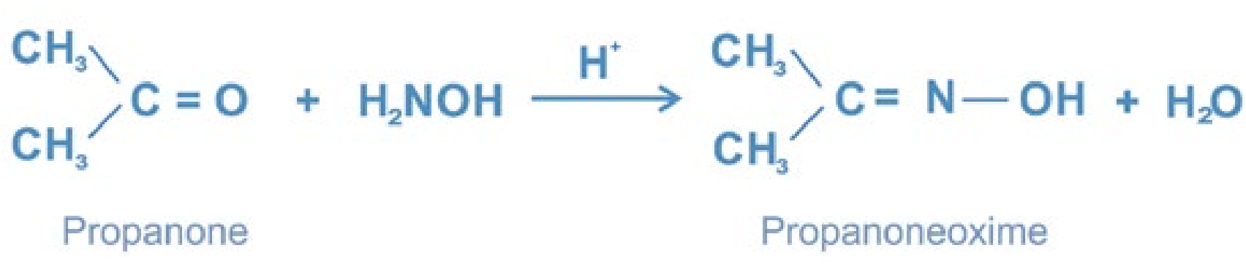

###### (ii) Reaction with Phenylhydrazine

Aldehydes and ketones react with phenylhydrazine to form phenylhydrazones in the presence of an acid

20

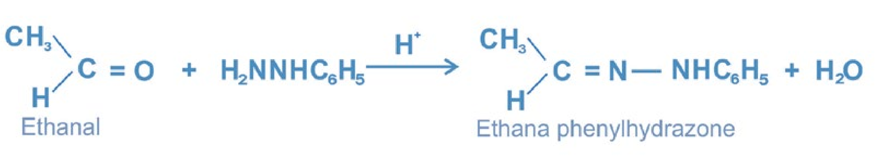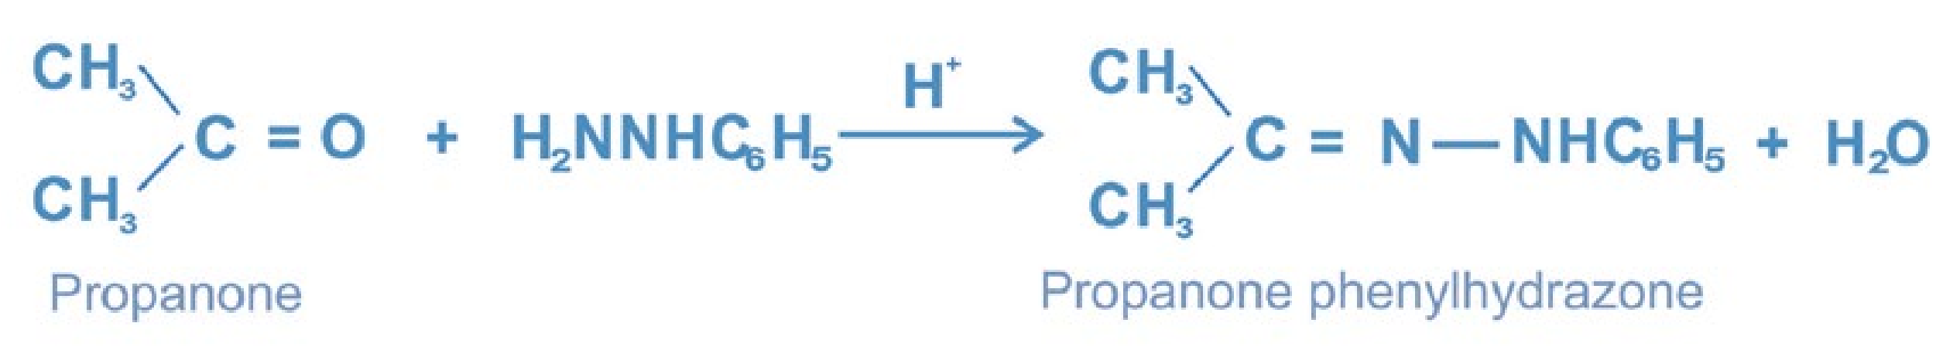

Ethanal

###### (iii) Reaction with Hydrazine

Aldehydes and ketones react with hydrazine to form hydrazones in the presence of an acid.

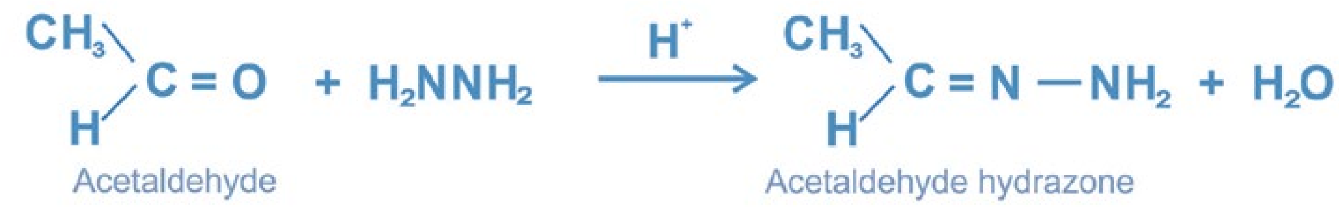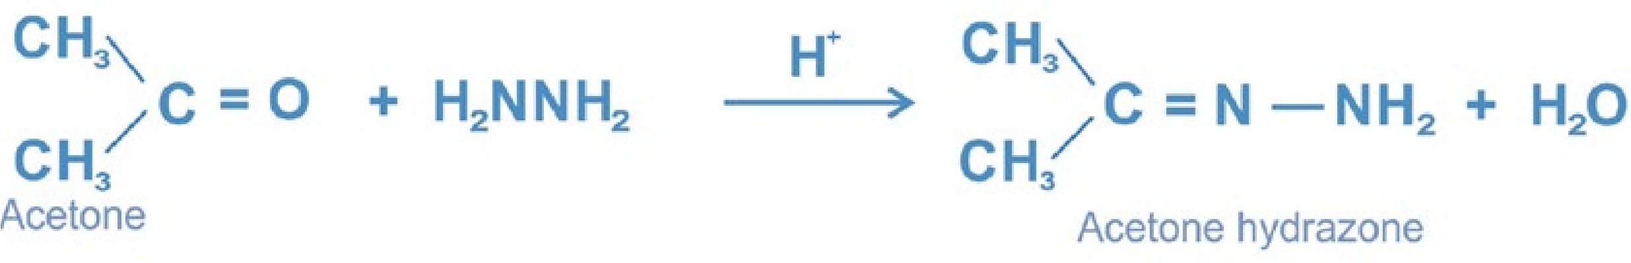

###### (iv) Reaction with 2 , 4 -Dinitrophenylhydrazine [ 2 ,4-DNPH ]

Aldehydes and ketones react with 2, 4-dinitrophenyhydrazine to form 2, 4- dinitrophenylhydrazones in the presence of an acid.

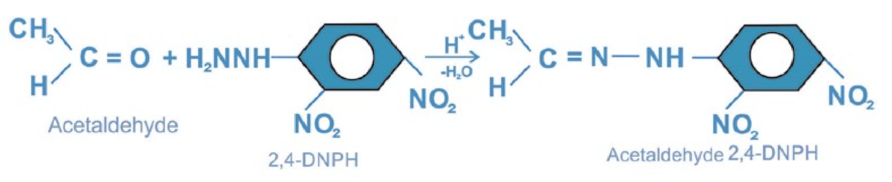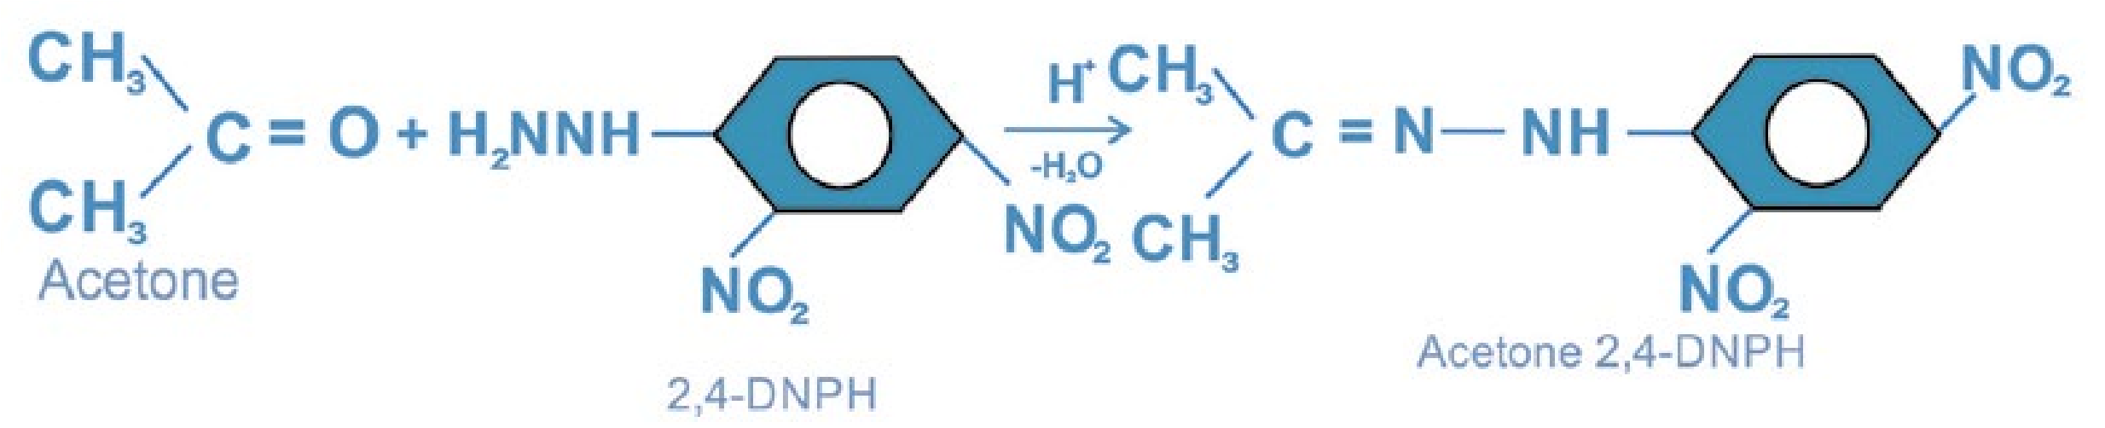

The reaction can be used for the identification of aldehydes and ketones because

2, 4-dinitrophenylhydrazones are usually yellow or orange crystalline solids

21

**Mechanism of the Reactions of Ammonia Derivatives** Step (i) Protonation of oxygen of the carbonyl group.

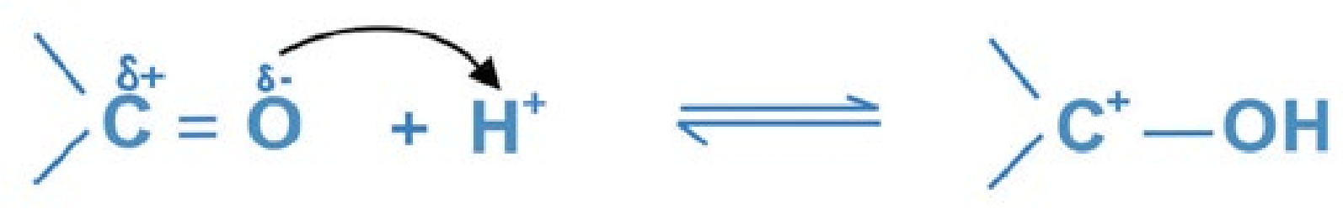

Step (ii) Nucleophilic attack of nitrogen of ammonia derivative on the electrophilic positively charged carbon and deprotonation of the adduct.

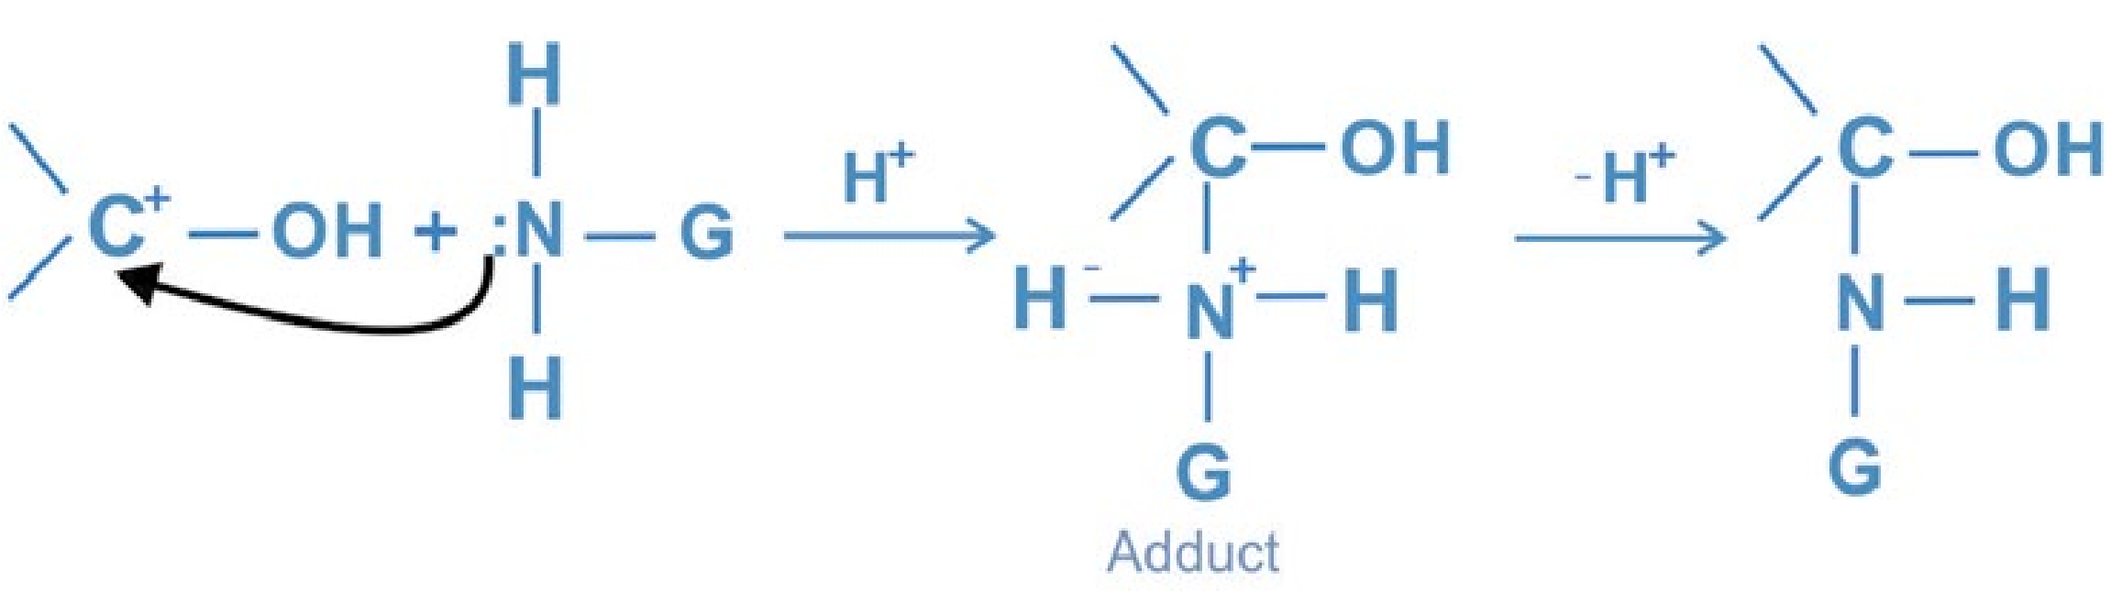

Step (iii) Protonation of oxygen of hydroxyl group followed by the removal of water.

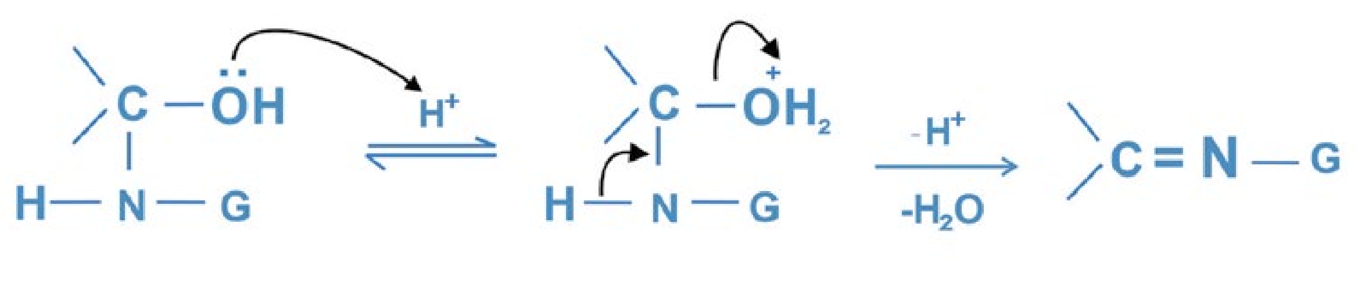

9. Addition of Alcohols

Aldehydes combine with alcohols in the presence of hydrogen chloride gas to form acetals. The hydrogen chloride gas acts as a catalyst. Both the alcohol and the hydrogen chloride gas must be dry.

22

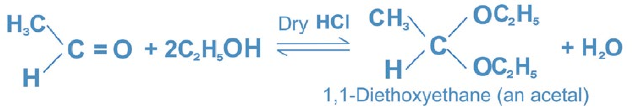

The reaction may be used to protect the aldehyde group against alkaline oxidising agents. To regenerate aldehyde, the acetal is hydrolysed in the presence of an acid.

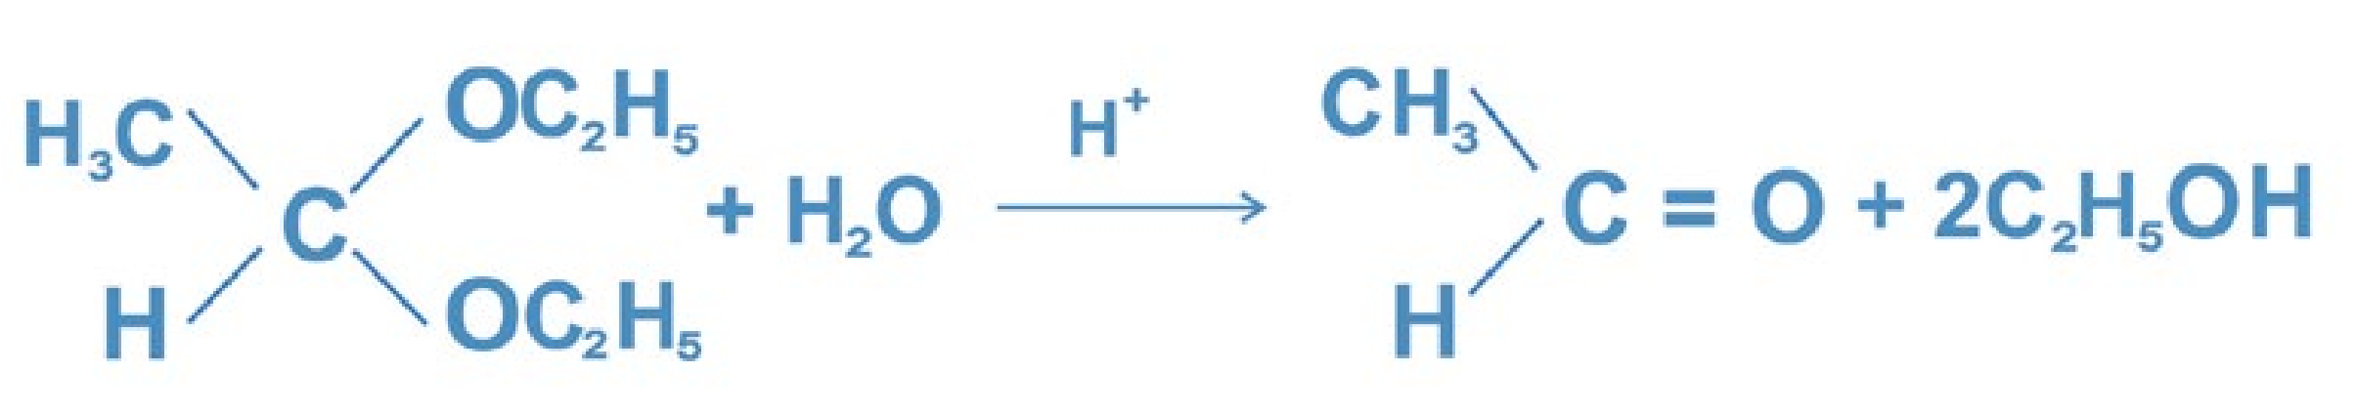

Ketones do not react under these conditions.

##### 12.5.2 Reduction Reactions

Aldehydes and ketones can both be reduced. Aldehydes are reduced to primary alcohols whereas ketones to secondary alcohols. The carbonyl group is converted into an alcohol. **(i) Reduction with Sodium Borohydride**

Aldehydes and ketones are reduced to alcohols with sodium borohydride, NaBH4. The reaction is carried out in two steps: reaction of the carbon compound with NaBH4 under anhydrous Conditions and then hydrolysis.

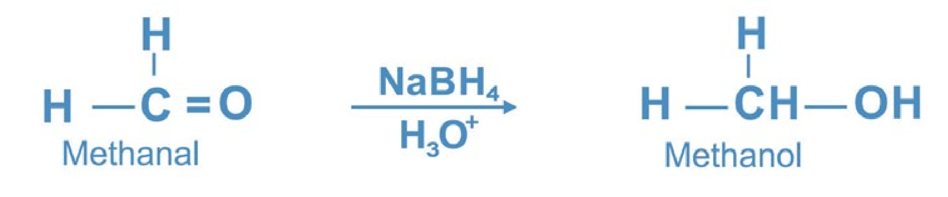

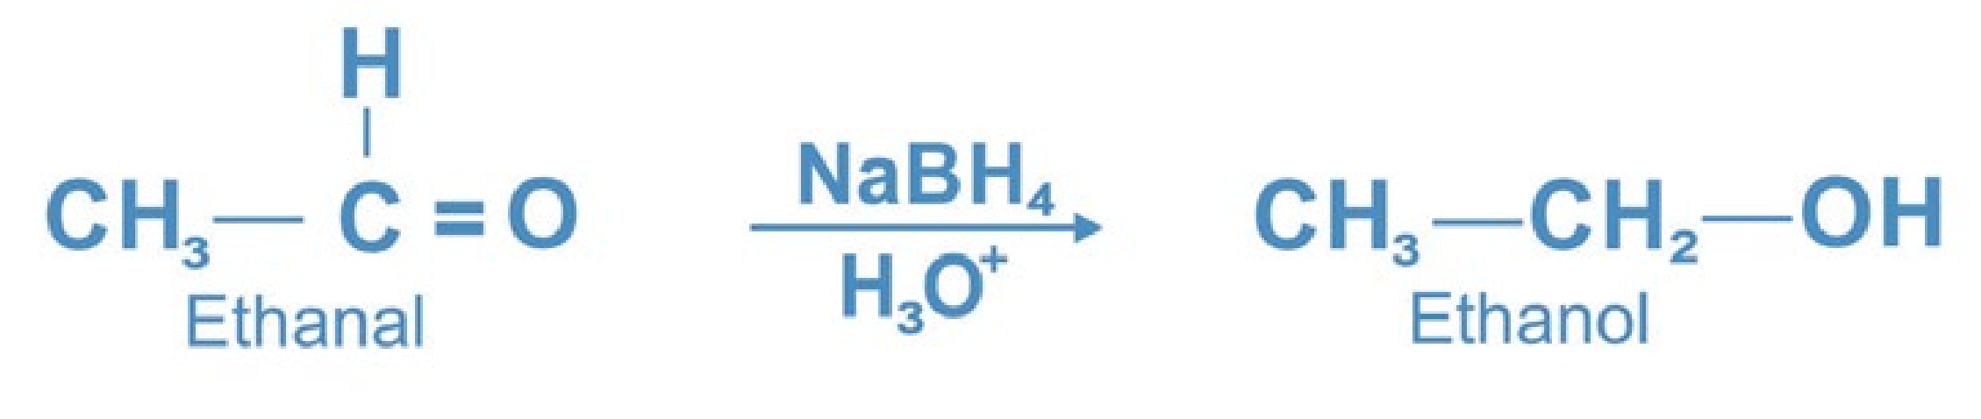

23

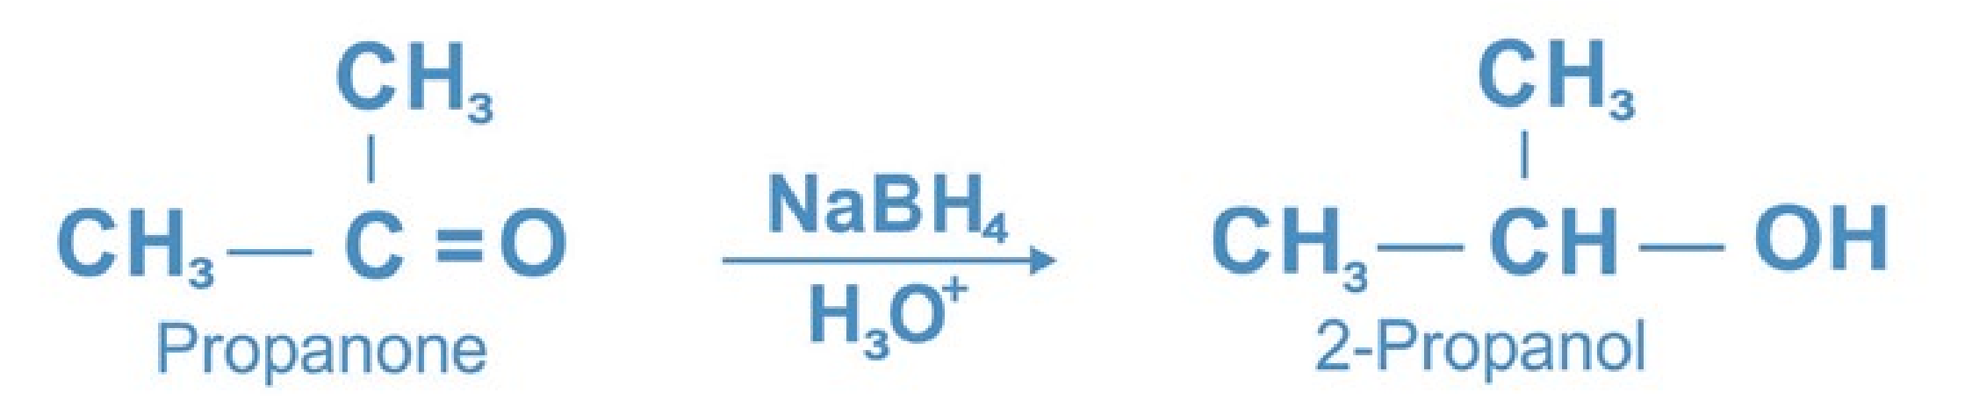

Sodium borohydride reduces the carbon-oxygen double bond but not the carbon-carbon multiple bond.

**Mechanism:**

The tetrahydridoborate (III) ion, BH4 is source of hydride ion, H-.The hydride ion acts as a nucleophile.It attacks on the electrophilic carbon of the carbonyl group to give an alkoxide ion.

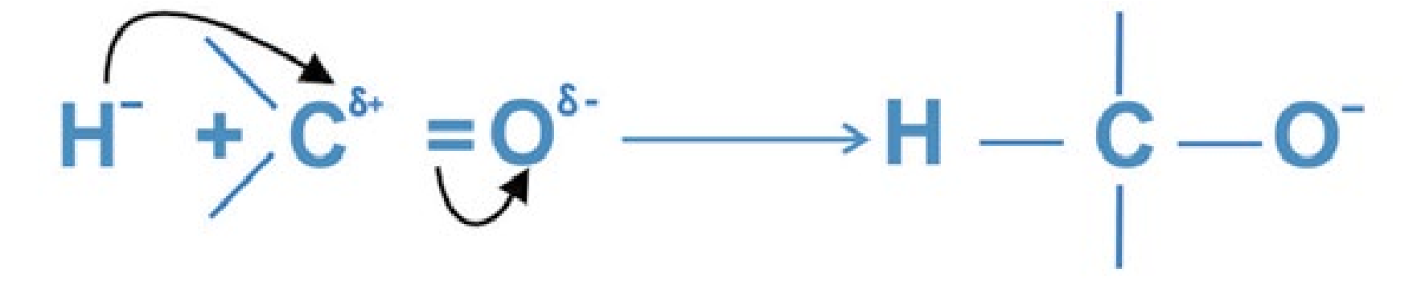

The alkoxide ion is protonated with water to give an alcohol.

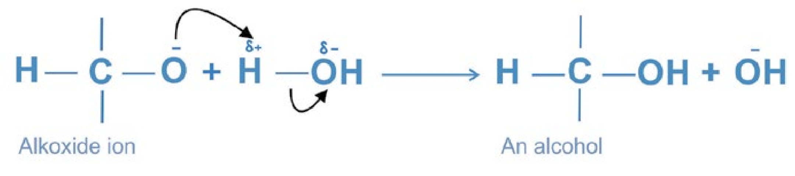

###### (ii) Catalytic Reduction

Aldehydes and ketones on reduction with hydrogen in the presence of a metal catalyst like Pd, Pt or Ni form primary and secondary alcohols respectively. Hydrogen is added across the carbonyl group.

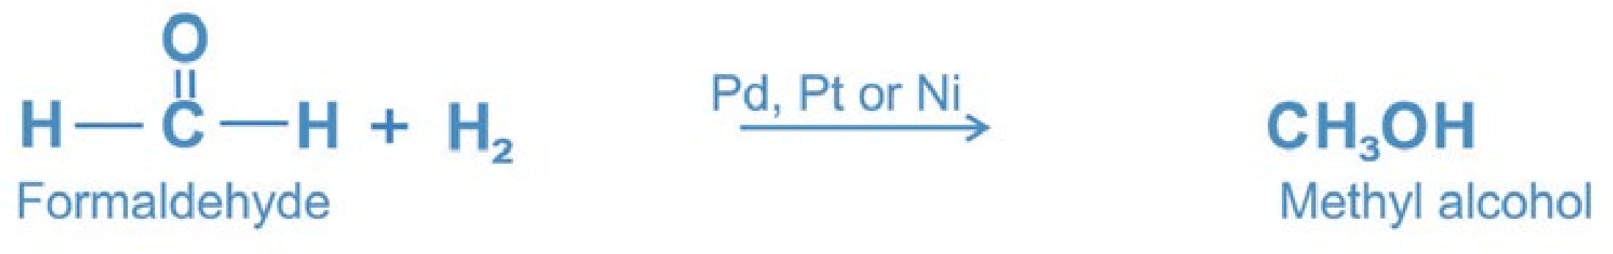

24

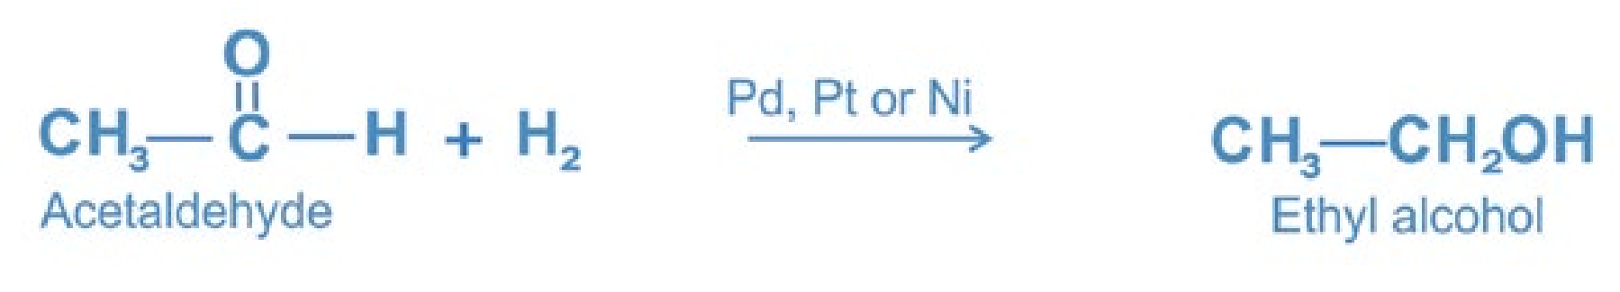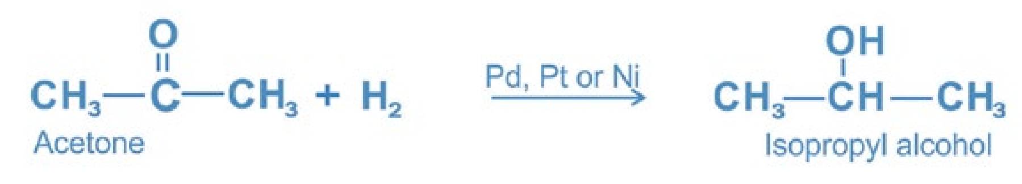

##### 12.5.3.Oxidation Reactions

1. **Oxidation of Aldehydes:**

Aldehydes are easily oxidised by mild oxidising agents like Tollen's reagent, Fehling's solution and Benedict’s solution. They are oxidised to carboxylic acids by strong oxidising agents such as K2Cr2O7 / H2SO4 , KMnO4 / H2SO4, and dilute nitric acid. The hydrogen atom attached to the carbonyl group in aldehydes is oxidised to OH group.

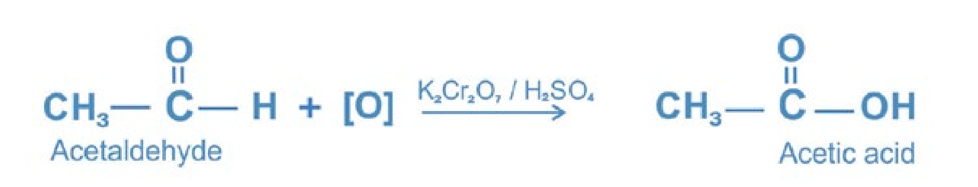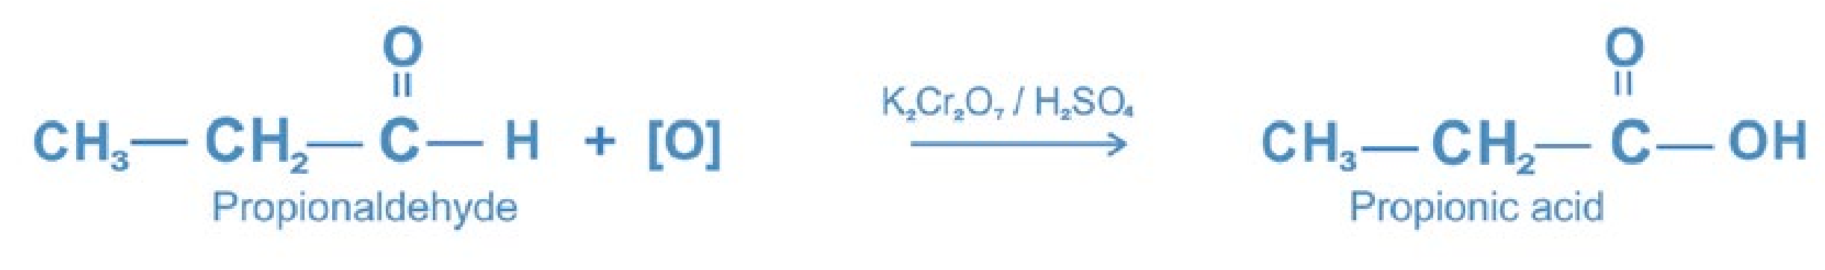

The carboxylic acid has the same number of carbon atoms as are present in the parent aldehyde.

1. **Oxidation of Ketones:**

Ketones do not undergo oxidation easily because they require breaking of strong carbon - carbon bond. They give no reaction with mild oxidising agents. They are only oxidised by strong oxidising agents such as K2Cr2O7 / H2SO4 , KMnO4 / H2SO4, and conc. HNO3. In oxidation of ketones, only the carbon atoms adjacent to the carbonyl group are attacked. The carbon atom joined to the smaller number of hydrogen atoms is preferentially oxidised. In case of symmetrical ketones only one carbon atom adjacent to the carbonyl group is oxidised and a mixture of two carboxylic acids is always obtained.

25

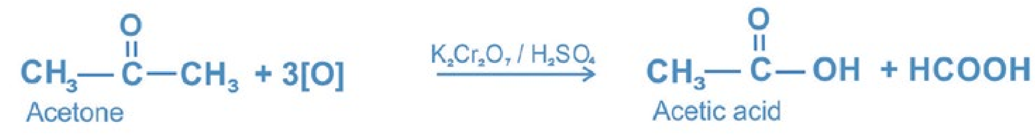

However, in case of unsymmetrical ketones, the carbon atom joined to the smaller number of hydrogen atoms is preferentially oxidised and the carbonyl group remains with the smaller alkyl group.

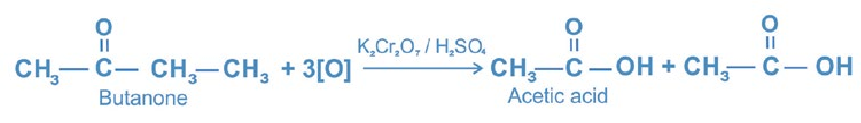

**2**

#### 12.6 IDENTIFICATION OF CARBONYL COMPOUNDS

Detection tests for aldehydes and Ketones.

1. **2,4 DNPH Test:** Aldehydes and ketones form a yellow or red precipitate with 2,4 dinitrophenylhdrazine solution.
2. **Sodium Bisulphite Test:** Aldehydes and small methyl ketones form a crystalline white precipitate with saturated sodium bisulphite solution.
3. **Tollen's Test [Silver Mirror Test]:** Aldehydes form silver mirror with Tollen’s reagent (ammoniacal silver nitrate solution). Add Tollen’s reagent to an aldehyde solution in a test tube and warm. A silver mirror is formed on the inside of the test tube.

High quality mirrors are manufactured by using this principle. Ketones do not give this test.

AgNO + 3NH OH3 4 →[Ag(NH )3 2]OH + NH NO + 2H O4 3 2

### R CHO + 2 Ag(NH )[ 3 2]OH → R-COONH + 2Ag + 2NH + H O4 3 2

Silver mirror

**4. Fehling’s Solution Test [an alkaline solution containing a cupric tartrate complex ion]:** Aliphatic aldehydes form a brick-red precipitate with Fehling’s solution. To an aldehyde solution, add Fehling’s solution and boil. A brick red precipitate of cuprous oxide is formed. Ketones do not give this test.

26

### AgNO + 3NH OH3 4 →[Ag(NH )3 2]OH + NH NO + 2H O4 3 2

Brick-red-ppt

**5. Benedict's Solution Test |an alkaline solution containing a cupric citrate complex ion]:** Aliphatic aldehydes form a brick-red precipitate with Benedicts's solution. To an aldehyde solution, add Benedict's solution and boil. A brick-red precipitate of cuprous oxide is formed

#### RCHO + 2Cu(OH) + NaOH2 → RCOONa + Cu O + 3H O2 2

Ketones do not give this test.

**6. Sodium Nitroprusside Test:**

Ketones produce a wine red or orange red colour on adding alkaline sodium nitroprusside solution dropwise. Aldehydes do not give this test.

##### 12.7 USES

###### (a) Uses of Fomaldehyde

1. It is used in the manufacture of resins like urea-formaldehyde and plastics such as bakelite.
2. It is used in the manufacture of dyes such as indigo, para-rosaniline, etc.
3. Its 40% aqueous solution called formalin is used as an antiseptic, a disinfectant, a germicide, a fungicide and for preserving animal specimens and sterlising surgical instruments.
4. It is used as a decolourising agent in vat dyeing.
5. It is used in the silvering of mirrors.
6. It is used in making medicine urotropine used as a urinary antiseptic.(vii) It is used in making formamint (formaldehyde + lactose) used as throat lozenges.

(viii) It is used in the processing of anti-polio vaccine.

27

###### (b) Uses of Acetaldehyde

1. It is used in the production of acetic acid, acetic anhydride, n-butanol, ethanol,

2-ethyl-1-hexanol, vinyl acetate, paraldehyde, ethylacetate, etc. Brick-red-ppt

1. It is used to make acetaldehyde ammonia used as a rubber-accelerator.
2. It is used to make chloral hydrate, ethanol trimer and tetramer. Chloral hydrate and ethanol trimer are both used as hypnotic drugs whereas ethanol tetramer is used as a slug poison.
3. It is used as an antiseptic inhalent in nasal infections.
4. It is used in silvering of mirrors.
5. It is used to make phenolic resins and synthetic drugs.

28

##### KEY POINTS

1. Aldehydes and ketones contain the carbonyl group, C = 0 as the functional group.
2. Both aldehydes and ketones can be prepared by the oxidation of primary and secondary alcohols respectively.
3. Both aldehydes and ketones undergo nucleophilic addition reactions. In these reactions, the negative part of the reagent combines with the electrophilic carbon of the carbonyl group whereas the positive part goes to the oxygen atom. They are base catalysed addition reactions.
4. Two molecules of the same carbonyl compound condense to form an aldol. Aldehydes and ketones containing a-hydrogen atoms undergo this reaction in the presence of dilute sodium hydroxide.
5. Aldehydes that have no a-hydrogen atoms undergo Cannizzaro’s reaction in the presence of concentrated sodium hydroxide.
6. Acetaldehyde and only methyl ketones react with halogens in the presence of sodium hydroxide to give haloform. It provides a useful method for converting a methyl ketone to a carboxylic acid containing one carbon atom less than the parent methyl ketone. Iodoform test is used for distinguishing methyl ketones from other ketones.
7. Aldehydes and ketones react with ammonia derivatives, G - NH2 to form condensation products containing the group, C = N - G and water. The reaction is acid-catalysed.
8. Aldehydes and ketones are reduced to alcohols with sodium borohydride. Aldehydes and ketones are also reduced to alcohols with molecular hydrogen in the presence of catalyst like Pd, Pt or Ni.
9. Aldehydes are oxidized to carboxylic acids. K2Cr2O7 in H2SO4 or KMnO4, in H2SO4 may be used as the oxidising agent. Ketones resist oxidation.
10. Aldehydes form silver mirror with Tollen's reagent. Ketones do not give this test.
11. Aldehydes give a brick red precipitate with Fehling's solution on boiling.

29

##### EXERCISE

**Q. 1 Fill in the blanks.**

1. Aldehydes are the first oxidation product of_____________________.
2. Ketones are the first oxidation product of_____________________.
3. Aldehydes and ketones undergo_________________ addition reactions.
4. Formaldehyde reacts with_________________ to give primary alcohol.
5. Acetaldehyde reacts with_________________ to give 2-butanol.
6. Aldehydes are strong_________________ agents.
7. The oxidation of an_________________ always gives a carboxylic acid.
8. The reduction of a_________________ always gives a secondary alcohol.
9. Formaldehyde gives_________________ test with Tollen's reagent.
10. Acetaldehyde gives a_________________ precipitate with Fehling's solution.

**Q. 2 Indicate True or False.**

1. Formaldehyde is used in the silvering of mirrors.
2. Ketones combine with alcohols in the presence of HCl gas to form acetals
3. Acetaldehyde undergoes Cannizzaro’s reaction;
4. Aldol condensation reaction is given by only those aldehydes and ketones which contain an a-hydrogen atom.
5. Cannizzaro's reaction is given by only those aldehydes containing no a-hydrogen atom.
6. Propanal and propanone behave differently with Tollen's reagent.
7. Acetone reacts with sodium bisulphite to give a yellow crystalline product.
8. Acetone on reduction gives a primary alcohol.
9. 40% aqueous solution of formaldehyde is called formalin.

30

**Q. 3 Multiple choice questions. Encircle the correct answer.**

1. The carbon atom of a carbonyl group is

(a) sp hybridized (b) sp2 hybridized (c) sp3 hybridized (d) none of these

1. Formalin is
2. 10% solution of formaldehyde in water
3. 20% solution of formaldehyde in water
4. 40% solution of formaldehyde in water(d) 60% solution of formaldehyde in water

iii) Which of the following will have the highest boiling point?

(a) Mathanal (b) Ethanal

(c) Propanal (d) 2-Hexanone

(iv) Ketones are prepared by the oxidation of

(a) Primary alcohol (b) Secondary alcohol (c) Tertiary alcohol (d) all of these

(v) Acetone reacts with HCN to form a cyanohydrin. It is an example of

(a) Electrophilic addition (b) Electrophilic substitution

(c) Nucleophilic addition (d) Nucleophilic substitution

(vi) Which of the following compounds will not give iodoform test on treatment with I2/NaOH:

(a) Acetaldehyde (b) Acetone (c) Butanone (d) 3-Pentanone

(vii) Which of the following compounds will react with Tollen’s reagent.

O O

(a) CH3 - C - H (b) CH3 - C - CH3

O O

(c) CH3 - C - OH (d) CH3 - C - CH2 - CH3

31

(viii) Cannizzaro’s reaction is not given by

(a) Formaldehyde (b) Acetaldehyde

(c) Benzaldehyde (d) Trimethylacetaldehyde

(ix) Which of the following reagents will react with both aldehydes and ketones?

(a) Grignard reagent (b) Tollen’s reagent

(c) Fehling’s reagent (d) Benedict’s reagent

**Q. 4** Give one laboratory and one industrial method for the preparation of formaldehyde.

**Q. 5** How does formaldehyde react with the following reagents?

(i) CH3MgI (ii) HCN (iii) NaHSO3 (iv) conc.NaOH

(v) NaBH4/H2O (vi)Tollen’s reagent (vii) Fehling’s reagent

**Q. 6** Give one laboratory and one industrial method for the preparation of acetaldehyde.

**Q. 7** How does acetaldehyde react with the following reagents?

(i) C2H5MgI (ii) HCN (iii) NaHSO3 (iv) dilute NaOH (v) I2/NaOH (vi) NaBH4/H2O (vii)NH2OH (viii) K2Cr2O7/H2SO4

**0 .8** Describe briefly the mechanism of nucleophilic addition to a carbonyl compound.

**Q. 9** Explain with mechanism the addition of ethylmagnesium bromide to acetaldehyde. What is the importance of this reaction?

**Q. 10** Explain with mechanism the addition of sodium bisulphite to acetone . What is the utility of this reaction?

**Q. 11** Describe with mechanism aldol condensation reaction. Why formaldehyde does not give this reaction?

32

**Q. 12** What types of aldehydes give Cannizzaro’s reaction? Give its mechanism.

**Q. 13** Explain the mechanism of the reaction of phenylhydrazine with acetone. **Q. 14** Using ethyne as a starting material how would you get acetaldehyde, acetone and ethyl alcohol?

**Q. 15** Give the mechanism of addition of HCN to acetone.

**Q. 16** How would you bring about the following conversions?

(i) Acetone into t-butyl alcohol (ii) Propanal into 1-propanol

(iii) Propanone into 2-propanol (iv) Methanal into ethanal

(v) Ethanal into propanone (vi) Ethanal into 2-propanol (vii) Ethyne into ethanal (viii) Ethene into ethanal (ix) Ethanal into ethanol (x) Ethanol into 2-butanone (xi) Methanol into ethanal (xii) Ethanol into ethanoic acid .

**Q. 17** How will you distinguish between:

(i) Methanal and ethanal (ii) Ethanal and propanone

(iii) Ethanal and propanal (iv) Acetone and ethyl alcohol

(v) Butanone and 3-pentanone (vi) Acetaldehyde and benzaldehyde (vii) 2-Pentanone and 3-pentanone

**Q. 18** Discuss oxidation of (a) aldehydes (b) ketones with:

(i) K2Cr2O7/H2SO4 (ii)Tollen’s reagent (iii) Fehling’s solution

**Q. 19** Discuss reduction of (a) aldehydes (b) ketones with

(i) NaBH4/H2O (ii) H2/Pd

**Q. 20** Give three uses for each of formaldehyde and acetaldehyde.